

TRIRIGA Building Information Models (BIM) User’s Guide

For TRIRIGA Platform 3.6

Technical Contact: Doug Wood [doug.wood@wipro.com](mailto:doug.wood@wipro.com)

Marketing Contact Paul Lacey [placey@us.ibm.com](mailto:placey@us.ibm.com)



The Maxim extensions for Building Information Modeling (BIM) is released as trial software and distributed on the IBM Service Management (ISM) Library. An existing Maximo Asset Management 7.5 or 7.6 license and installation is required. Trial software is not supported by the IBM Maximo support program; however, support is available directly from the IBM Maximo development team for as long as the software is available for download on the ISM Library. Check the ISM Library for the most recent version as well as continued availability. Only an English version is distributed during the trial. Your feedback is important because the software is being evaluated for possible integration with other Maximo products. Send all support questions and feedback to: [maxbim@ca.ibm.com](mailto:maxbim@ca.ibm.com)



**© Copyright International Business Machines Corporation 2018.**

US Government Users Restricted Rights – Use, duplication or disclosure restricted by GSA ADP Schedule Contract with IBM Corp.

Contents

List of Figures vi

1 Overview 9

1.1 Utilizing Building Information Modeling (BIM) models with TRIRIGA 9

1.2 Supported Software 9

1.3 Features 9

2 BIM Connector for Revit 10

2.1 User 12

2.1.1 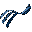 Log In 12

2.1.2  Servers 13

2.1.3  Log Out 14

2.2 Setup 14

2.2.1  Project Settings 14

2.2.2  Populate Parameters 17

2.2.3  Map Areas to Rooms 18

2.2.4  Space Use Class 22

2.3 Integrate 24

2.3.1  Building 26

2.3.2  Levels 28

2.3.3  Rooms 30

2.3.4  Spaces 33

2.3.5  Assets 36

2.3.6 Detach 38

2.4 Update 39

2.4.1 Sync 39

2.4.2 Publish Floor Plans 40

2.4.3 Publish Model 40

2.5 Open in TRIRIGA 41

2.5.1 Open Building 41

2.5.2 Open Selection 41

2.5.3 Launch Portal 41

2.6 Help 41

2.6.1 Info 41

3 Autodesk Forge Model Administration 41

3.1 Setting up the Forge Service 42

3.1.1 Register with Autodesk Forge and Create an application 42

3.1.2 Entering Forge Credentials into TRIRIGA 45

3.1.3 Configure TRIRIGA for access to Forge Management tool 46

3.1.4 Autodesk SSL Certificate 47

3.2 Exporting Navisworks Models 50

3.2.1 Exporting the model 50

3.2.2 Enhancing the model 51

3.3 Importing models into the Forge Service 51

3.3.1 Managing Model Storage 52

3.3.2 Managing Model Files 54

3.3.3 Upload Model 56

3.3.4 Associating Translated Models with Buildings 60

3.3.5 Previewing Models in the Viewer 62

4 Using the Autodesk Forge Viewer 63

4.1 TRIRIGA context 63

4.2 Viewer Navigation 63

4.2.1 Viewer Toolbar 63

4.2.2 Model Tree 65

4.3 Sections 66

4.4 Saved views 67

4.5 Markup 70

5 Best Practices 73

6 Troubleshooting 74

6.1 Forge Viewer 74

6.2 BIM Connector for Revit 75

6.3 Known Limitations 76

7 Appendix REST API support 76

List of Figures

Figure 1 - BIM Connector for Revit Toolbar 10

Figure 2 - Login Form 12

Figure 3 - Server definition list 13

Figure 4 - Server Definition Form 14

Figure 5 - Project Configuration Form 15

Figure 6 - Parameter value creation rule form 16

Figure 7 - Populate Parameters Form 17

Figure 8 - Link Areas to Rooms Form 21

Figure 9 - Space Use Classification Form 23

Figure 10 - Integration Error Form 25

Figure 11 - Building Integration Form 27

Figure 12 - Levels Integration Form 28

Figure 13 - Rooms Integration Form 31

Figure 14 - Space Integration Form 34

Figure 15 - Asset Integration Form 37

Figure 16 - Synchronize with TRIRIGA Form 39

Figure 17 - Publish Floorplan Form 40

Figure 18 - Publish Model Form 41

Figure 19 - Model Integration Process 42

Figure 20 – Create an Autodesk® Forge application 43

Figure 21 – Forge application definitions 44

Figure 22 – Forge application credentials 45

Figure 23 – Configure Forge Credentials in TRIRIGA 46

Figure 24 – TRIRIGA BIM User Security Group. 47

Figure 25 - Model Upload 56

Figure 26 - Translated Viewable (bubble) Details 59

Figure 27 - Building to Model Link 61

Figure 28 - Building to Model Link Details 62

Figure 29 - Forge Viewer Toolbar 64

Figure 30 - TRIRIGA Extension to the Forge Viewer Toolbar 64

Figure 31- Forge Viewer Model Tree 66

Figure 32 - Forge Viewer Section Tool 67

Figure 33 - Saved View Dialog 68

Figure 34 - Apply View Dialog 68

Figure 35 - Manage Forge Views Popup 69

Figure 36 - Forge Viewer Markup Toolbar 70

Figure 37 - Save Markup Dialog 72

Figure 38- Display Markup Dialog 73

**Executive Summary**

The TRIRIGA 3.6.0 platform provide integration with Building Information Models (BIM) to enable initialization of facilities data at building hand-over, and to support facilities management operations. There are two primary integration points for BIM data:

* **The BIM Connector for Revit**: This provide initial population of TRIRIGA facility data from Revit authored models, and provide ongoing synchronization of data between TRIRIGA and Revit models during operations.
* **The Autodesk Forge viewer**: This provide in context 3D visualization of BIM data from TRIRIGA applications.

**BIM Connector for Revit**

The BIM Connector creates TRIRIGA building, floor, spaces, and asset records from Revit models, including linked models. It synchronizes key attributes over the life of the building. It can publish floor plans for use in the TRIRIGA floorplan viewer.

**Forge Viewer**

The Forge viewer is integrated into the Locate and Work Task applications providing in context 3D visualization of spaces and asset, access to model properties, and model markup.

**BIM Model Management**

All of the interaction with the Autodesk Forge service required to manage the models used by the Forge viewer can be performed from within TRIRIGA using an intuitive graphic interface

**Change History**

#### Version 2.6.0

New

# Overview

## Utilizing Building Information Modeling (BIM) models with TRIRIGA

Building Information Models are an industry representation of a building that are used during the design and build phases of building construction. The data model provides the information in its attributes to describe (in detail) the infrastructure of a building. The use of data models is becoming more frequently used by contractors and is part of the turnover of a building to the owner. A model that is provided at turnover is generally referred to as the “as built” state of the building.

Building owners who are commissioning a building into production need the information in this model to perform facilities management. The process of loading this information into your maintenance products, such as Maximo, is costly, time consuming, and may introduce errors. The TRIRIGA BIM support allows you to load data from a Revit® model into TRIRIGA to begin the process of maintaining the building. This state is referred to by “as maintained”.

When the data is imported, TRIRIGA provides 3D visualization of the full building model in context with the imported data. This improves the efficiency of the maintenance, work planning, and execution process. Finally, changes made during operations may be synchronized with the.

## Supported Software

TRIRIGA Platform 3.6.0

TRIRIGA Application 10.6.0

TRIRIGA BIM Connector for Revit 2.6.0

Autodesk Revit 2017, 2018, 2019. 2016 had been observed to work, but is not supported.

**Autodesk Forge Viewer:** The Autodesk Forge Viewer is a cloud-based Viewer. To use it in TRIRIGA, a subscription from Autodesk is required. The Forge Viewer requires a browser that supports WebGL.

## Features

The Forge Viewer integration provides visualization of Building Information Model (BIM) data in the context of the TRIRIGA Assets, Locations, and Work Tasks applications. In this context, it provides the following features:

**BIM Connector for Revit**

The BIM Connector for Revit is used to integrate BIM models authored in Revit with TRIRIGA. It can create new TRIRIGA records from model elements, or link model elements to existing TRIRIGA records. Once linked, a limited set of values can be synchronized between TRIRIGA and the model.

Floorplans can be published from Revit directly into TRIRIGA, for use in the TRIRIGA floorplan viewer. Rooms in the floorplan are automatically linked to TRIRIGA spaces created from or linked to Revit rooms.

The Revit model can be published to the Forge service either directly from Revit or indirectly through Navisworks. This enables the model to be viewed in the Forge viewer

**Forge Viewer**

The Forge viewer is embedded in Locate and Work Task applications.

TRIRIGA Space and BuildingEquipment records created from or linked to Revit elements can be selected in the Forge viewer. And the full set of model properties are available in the viewer

* Full 3D navigation
* Basic search
* Model properties
* Model tree
* Sectioning of a model
* Model walk through
* Save and restore views
* Markup

**BIM Model Management Tool**

A UI for administering the Autodesk Forge service as used by TRIRIGA including:

* Managing storage containers (Autodesk Forge Buckets)
* Uploading models to the Autodesk Forge service
* Translating models into viewable formats
* Associated models with TRIRIGA building records
* Manage saved views

# BIM Connector for Revit

The BIM Connector for Revit is a Revit add-on access from with Revit. It adds a ribbon to Revit with the TRIRIGA integration functions.



Figure 1 - BIM Connector for Revit Toolbar

The standard workflow is from left to right across the ribbon. Items on the ribbon are context aware and are only enable when the operation they start is legal. They are affected by:

* Whether or not the connector is logged into TRRIGA
* If pre-requisite steps have been completed
* If an integration operation is in progress

#### Shared Parameters

The BIM Connector for Revit adds several Shard Parameters to the Revit Elements that can be integrated with TRIRIGA. The values in these parameters are used for the initial creation of TRIRIGA records from Revit Elements, then can later be updated to reflect changes made to the linked TRIRIGA records. The parameters visible to users include:

All Elements

* IBM.Name
* IBM.Description
* IBM.isTRIRIGA (read-only)

Project Information

* IBM.ModelName
* IBM.ModelDescription
* IBM.BuildingName
* IBM.BuildingDescription

Level

* IBM.Level

Rooms and Spaces

* IBM.UseClassification

Components

* IBM.BarCode

Tools described below are provided to manage the values off all of these. They may also be edited individually from the appropriate object property sheet or schedule. There are also several hidden parameters that don’t appear on the property sheets, but can be added to schedules. These should not be edited by modelers.

#### Filtering lists

Most lists and trees can be filter to help find the desired value. This is indicated by a filter entry field above the list or tree.



To filter a list:

* Enter text in the filter field
* Press Enter to apply the filter or wait a few seconds and it is applied automatically. Any entry that contains the filter text is displayed (substring match)
* To clear the filter and restore the full list, click the clear button to the right of the filter field or just delete the filter text.
* If the list being filtered is a tree, then parent nodes of any child that matches the filter are also displayed even if they don’t match the filter.

#### Integration Process

The process of creating TRIRIGA records happens in two stages:

1. The Revit data is copied to the TRIRIGA server and stored in staging tables which are found in the triBIM module. Staging records are updated or created as necessary.
2. Publish workflows are run on the staging table records which create or update the application objects. The workflow may also update the staging records from the application records and these updated may flow back to the Revit model

The connector runs a background process that monitors the progress of the workflows, and retrieves any errors for display in Revit.

The connector stores a globally unique identifier (GUID) in each model file when it is integrated. This links the model to the TRIRIGA building record. Both staging and application records that are created from or linked to Revit elements are tagged with the linked Revit element unique ID. This is used both to link the Revit element and the TRIRIGA record, and to associate TRIRIGA records with graphic elements in the Forge viewer.

## User

The user section manages the connection to TRIRIGA servers.

### Log In

The connector require at least one pre-defined server configuration before a user can log into TRIRIGA. If none exists, and empty one is created called “environment”. It must be populated with a server configuration.

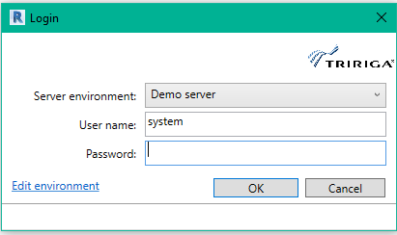

Figure 2 - Login Form

Select the desired server configuration. The user is populated from the configuration, but may be edited. The password is not saved and must always be provide.

If the configuration needs to be edited, it can either be edited here by selecting the edit environment link or from the servers from.

### Servers

The connector maintains a list of TRIRIGA server definitions.

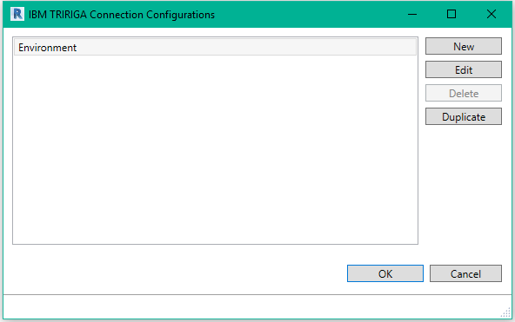

Figure 3 - Server definition list

To create or edit a server configuration, Display the Environment Connection Settings form.

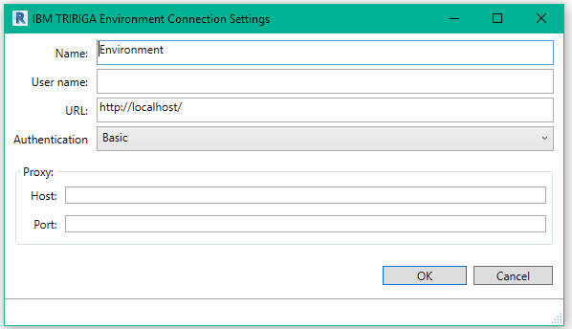

Figure 4 - Server Definition Form

**Name:** The name of this configuration. It is displayed on the login dropdown and in the Connections Configurations list. It is only visible to the current uses on the current workstation.

**User Name:** The user ID to use for TRIRIGA login. This is a convenience and may be edited later.

**URL:** The URL of the TRIRIGA server. This is the base URL used to access the TRIRIGA portal. That is hostname, port, and context root.

**Authentication:** The Authentication mechanism used by the TRIRIGA server. If you are unsure how your TRIRIGA server is configured, try each method to see which one succeeds.

Proxy: If you must pass through a proxy server to assess the TRIRIGA server, specify it here. This is usually the same configuration that is required for your browser to access TRIRIGA.

The server configurations are stored in a property file on the workstation running Revit on a per user basis. The file is located at:

<Current User>AppData\Local\IBM\TRIRIGA\AR Integrator\ environments.properties

### Log Out

Disconnect from TRIRIGA.

## Setup

The setup section covers model configuration tasks that must be performed before the model is integrated with TRIRIGA. Most of these are independent of the TRIRIGA server.

### Project Settings

The initial values of Name, and BarCode properties are created from other Revit parameters. As part of the connector setup, rules must be defined for how the values for these parameters are created. Rules are defined for each Revit Element type.

Use the Project Settings form to access the rule definitions.

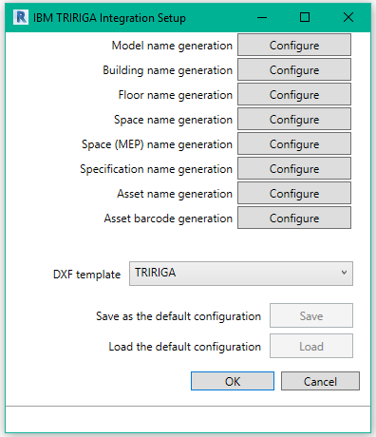

Figure 5 - Project Configuration Form

The button associated with each element type displays the dialog for creating a parameter value rule. The dialog is the same for all element types, although the values in the parameter dropdown differ. Rules must be defined in sequence from top to bottom. Each button is enabled when the preceding rule is defined.

**DFX Template:** Sets a default DFX template for use in publishing floorplans. The value becomes the default pre-selected template in the Publish Floorplan form. If the configuration is loaded from the server, and the template that is stored on the server doesn’t exist in the model, this value is empty.

**Save:** Saves the complete configuration to the TRIRIGA server. (you must be logged in for the button to be active)

**Load:** Loads the complete configuration from the TRIRIGA server overwriting any existing configuration. (you must be logged in for the button to be active)

Use the Name Generation Configuration from to define parameter value generation rules.

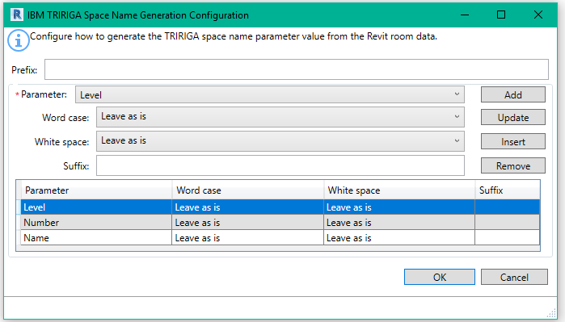

Figure 6 - Parameter value creation rule form

**Prefix:** A static text string that is applied once at the beginning of the name.

**Parameter:** The dropdown displays a list of all user visible parameters that are defined for the element type. It also exposes some non-parameter values of the element. A value generation rule requires at least one parameter and may have any number of additional parameters.

For rules that apply to components and types, only parameters that are associated with every supported category are included in the Parameters dropdown

There are several ways the original parameter value can be manipulated before it is used:

* Word case: This provides options for case folding and capitalization of the parameter value
* White space: This provides options for normalizing the white space contained in a parameter value.
* Suffix: This is static text that is appended to the end of the value of the referenced parameter. It is useful for adding separators between parameters.

**Add**: Adds the parameter definition at the end of the list.

**Update**: Replaces the selected parameter definition with the current definition

**Insert:** Inserts the parameter definition before the selected definition

**Delete:** Deletes the selected definitions

|  |  |
| --- | --- |
| Tip | *Use the ability to save confirmation to and load it from the TRIRIGA server to insure consistent rules are used across all models.* |

|  |  |
| --- | --- |
| Tip | *Including the element ID in Component names, Type Names, and Barcodes can help with uniqueness.* |

|  |  |
| --- | --- |
| Tip | *The parameters added by the COBie toolkit appear in the Parameters dropdown. You can effectively use the COBie rules instead of defining rules here by selecting just the COBie.name parameter for each element.* |

The project settings are stored in the model file.

### Populate Parameters

Before a model can be integrated with TRIRIGA, the shared parameters required by TRIRIGA must be added to the model, and have values assigned according to the rules defined above. This is done with the Populate Parameter tool.

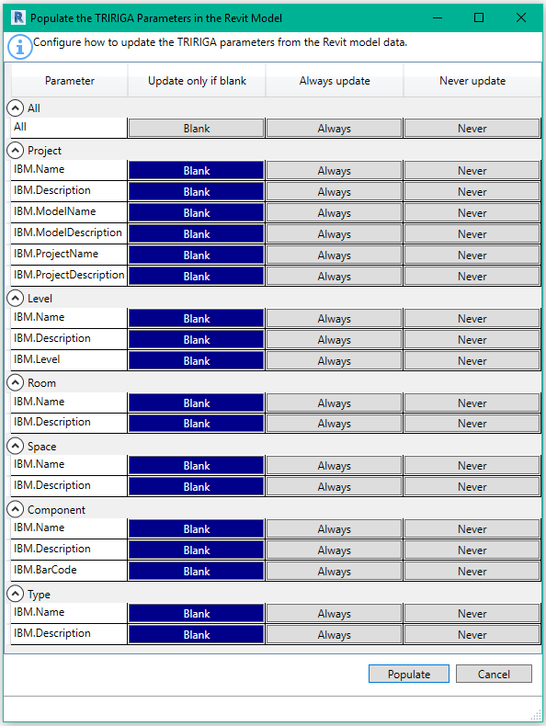

Figure 7 - Populate Parameters Form

There are 3 update options for each parameter.

* Blank: Only update the value if it is blank. This implies that either Populate Parameters has never been run, or the element has been added since the last time it was run.
* Always: Overwrite any existing value:
* Never: Don’t populate.

It is usually only necessary to run populate parameters before the initial integration and before newly added elements are integrated. Blank works well for this if one of the forms report error, it may be necessary to use Always to overwrite the values with corrections. Once an element is linked to TRIRIGA or if it is integrated with an existing TRIRIGA record, the name value is retrieved from TRIRIGA.

### Map Areas to Rooms

Revit uses Area Plans to support space planning. Area plans are used to calculate space and floor area. Revit support two types of Area Plans:

* Gross Building: Only one is allowed.
* Rentable: Area is calculated according to the BOMA 98 standard. A model may define any number.

Area plans are divided into areas. Areas are drawn onto the floorplan and need not have any relationship to Rooms or Spaces. This means that there are 4 possible relationships between an Area and a Room:

1. The area boundaries match the room boundaries.   
   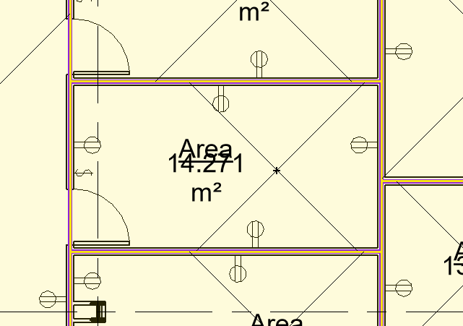
2. A room is comprised of exactly n areas. That is, none of the area boundaries for areas within the room cross the room boundary, and there is more than one area within the room  
   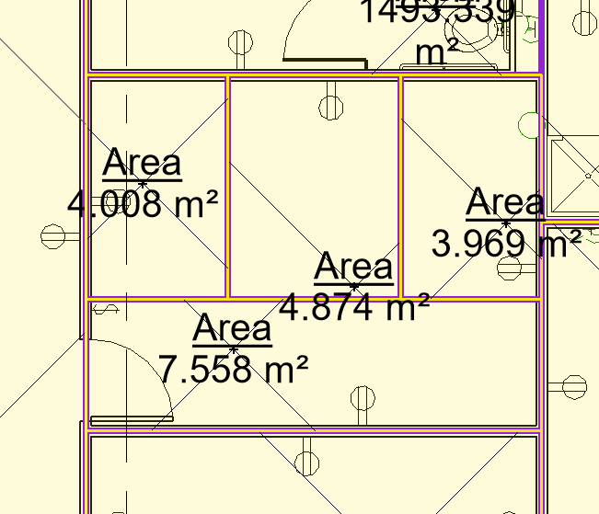
3. An area is encompassing exactly n rooms. That is, none of the room boundaries for rooms within the area cross the area boundaries, and there is more than one room within the area, and the area is completely filled by rooms.  
   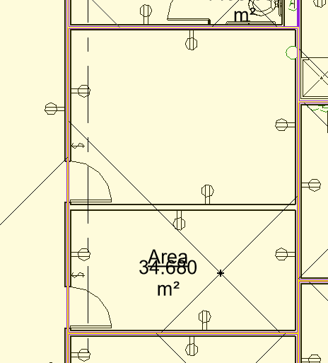
4. Areas are arbitrary: area and room boundaries cross area boundaries.  
   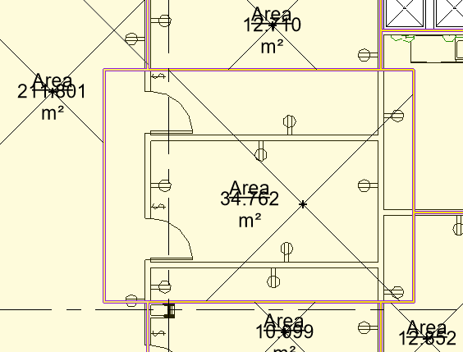

The connector can use area plans to calculate TRIRIGA floor area and Areas to calculate TRIRIGA Space area. Since there is only one gross area plan allowed, if it exists, it is used to calculate gross floor area. The rentable area plan must be specified. And areas can be linked to rooms assuming areas are specified as described in case 1 above. When an area is linked to a room, the Revit room area is replaced by the area from the Area.

Use the Map Areas to Rooms tool to manage the association of area to room, and to select the desired rentable area plan. When this form is first opened, it displays the current room to area linkage in the model, and the active rentable area plan. The tool is only active if there are Area Plan(s) defined in the model.

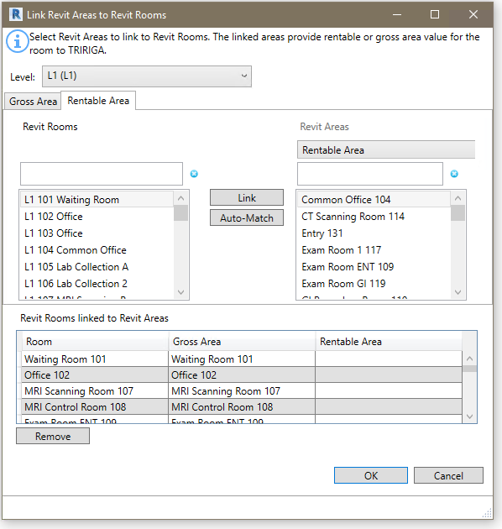

Figure 8 - Link Areas to Rooms Form

The form has several parts so some care should be taken to ensure you are working in the right context.

**Level:** Area Plans and Areas are associated with Revit levels, so the level selection controls the context of the rest of the form. The Rooms, Area Plans, and Areas displayed are all for the level selected in the Level dropdown.

**Gross Area/Rentable Area:** The form has two tabs which control the type of area plan displayed. These tabs are almost identical, except the rentable table requires selection of the Area Plan. Since only one Gross Area plan is allowed, no selection is required.

**Revit Rooms:** This displays the list of Rooms on the Level not linked to an Area in the selected Area Plan.. Each Area Plan has its own set of Rooms.

**Revit Areas:** For the Gross Area Plan, this displays the list of Areas defined for the Area Plan. For Rentable Area Plans, the Area Plan must be selected. The list of areas displayed is for the selected Area Plan. The selected Area Plan also controls what is displayed in the last column of the link table.

**Link:** When an entry is selected in both the Rooms and Areas list, pressing Link associates them removing them from their respective lists and adding them to the Linked Rooms and Areas table in the correct columns.

**Auto Match:** Auto match performs an exact name match of each room against the displayed area list. Each matching pair is linked as above.

**Revit Rooms linked to Revit Areas:** The table displays the room to area linkage that will be applied to the model if the form is accepted. Pay attention to the rentable area column as it changes based on the selected rentable area plan.

**Remove:** Removes the highlighted row(s) from the linkage table returning the rooms and areas to their respective lists.

The association between Area and Rooms is stored with the Rooms in hidden parameters.

|  |  |
| --- | --- |
| Tip | *Even if you don’t map rentable areas to rooms, select a rentable area plan for use in calculating floor rentable area.* |
| Tip | *If you have worked with more than one rentable Area Plan, be sure that the correct one is selected when you accept the form. Only the mappings for the selected Area Plan are saved and used.* |

### Space Use Class

TRIRIGA requires all spaces to have a space Use Classification specified, therefore, to create TRIRIGA spaces for Revit rooms or spaces, a Use Classification needs to be provided. The Space Use Class tool retrieves the Use Classification hierarchy from the TRIRIGA server and allows Use Classification to be assigned individually or in bulk to Revit rooms and spaces. They are stored in the IBM.UseClassification parameter. These values are then used when TRIRIGA spaces are created from the Revit objects. Once a Revit Room or Space is integrated with a TRIRIGA space, TRIRIGA is the master for Use Classification so updates here have no effect and are overwritten by a Sync operation.

|  |  |
| --- | --- |
| Tip | *The Integrate Room and Integrate Space tools both verify that a Use Classification is assigned, and does not display the Room or Space if it is missing. However, the Use Classification is only used for creating new TRIRIGA spaces. Specify Use Classifications for Rooms and Spaces for you intend to create new TRIRIGA spaces, then use the Assign Blank function to set the remainder to a default value.* |

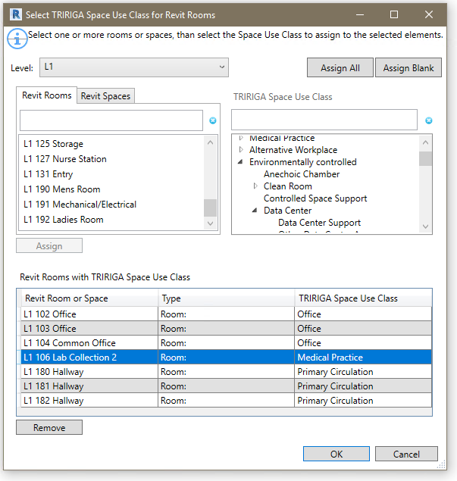

Figure 9 - Space Use Classification Form

**Level:** A list of all Revit levels. The selected level sets the context for the Revit Rooms and Revit spaces tabs.

**Revit Rooms**: All of the Rooms on the selected Level that don’t have Use Classifications assigned.

**Revit Spaces**: All of the Spaces on the selected Level that don’t have Use Classifications assigned, and aren’t linked to a room either by Revit, or by the Connector Spaces tool described below. If Rooms and Spaces are defined in the same model, and a Room and a Space share the same boundary, then Revit links them.

|  |  |
| --- | --- |
| Tip | *Use Classification is only used for Spaces if a TRIRIGA Space is directly created from the Revit Space. This is rare as Revit Spaces are typically linked to TRIRIGA Spaces created from Rooms. You can bulk assign a Use Classification to spaces, then individually edit any that will be directly integrated.* |

**Revit Rooms with TRIRIGA Space Use Class**: This shows the current list of rooms and spaces that have the have Use Classifications assigned, and their assigned value. When the form is initially opened, this displays the current state of the model.

**Assign**: When a Use Classification is selected, and at least one Room or Space is selected, this button is active. Pressing it assigns the Use Classification to all selected Rooms and Spaces, removes the Rooms and Spaces from their respective list and add them to the assigned table.

**Remove**: Removes all selected rows from the assigned table, clears the Use Classification value and returns them to their respective lists.

**TRIRIGA Space Use Class**: The space use classification hierarchy from the server to which the connector is logged into. This is retrieved at the time of login.

**Assign All:** Assigns the selected Use Classification to all rooms and spaces on all level. Any previously assigned value is overwritten. All Rooms and Spaces are moved to the assigned table with the new value.

**Assign Blank:** Assigns the selected Use Classification to all rooms and spaces on all level that don’t currently have a value. All Rooms and Spaces are moved to the assigned table with the new value.

Use Classifications are only used for creating new TRIRIGA spaces. When integrating with existing spaces, or when synchronizing the model with TRIRIGA, the Use Classification is updated from the linked TRIRIGA space.

## Integrate

The integrate steps generally need to be performed in the order presented here. This builds up the TRIRIGA location hierarchy. In addition, when working with federated models, the architecture model, or the model containing the majority of the room definitions should be the first model integrated. Additional models in the set are integrated as linked models.

All of the integration forms use a two-step process:

* Data is uploaded to the triBIM staging tables on the TRIRIGA server. This is synchronous and Revit cannot be used during its execution.
* The data is published via integration workflows from the triBIM object to the application objects. This happens asynchronously on the TRIRIGA server. The connector monitors the process. Many of the connector tools are not available while a publish action is running on the server.

#### Validation

Each form performs validation on the values of the parameters added by TRIRIGA to the primary object handled by the form, for example, Levels. If errors are found, the View Errors button is visible in the lower left corner of the form with an error count.



The View Errors button provides a list of error types and under each type a list of erroneous elements.

Note: Elements with errors are not displayed in the form and are not available for integration.

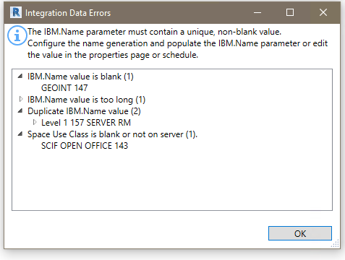

Figure 10 - Integration Error Form

#### Confirmation

Each form request confirmation before initiating the integration process. The request provides a general description of the action that will be performed.

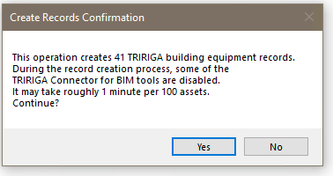

#### Linked Models

Many models are composed of several federate or linked files. These are often organized by discipline. The linked files contain many assets that are of interest to TRIRIGA users. However, the asset information is much more useful if the assets are correctly placed in the TRIRIGA location hierarchy. Linked model files often echo special elements from the primary, usually architectural, model file: Levels are duplicated across the files set. MEP Spaces are often, from a facilities management perspective, identical to Rooms.

The primary task of integrating a linked model file is to match the congruent spatial elements to the master elements in the primary integration file. Once the match is made, the connector writes the GUID of the matched element into a hidden parameter in the linked file. When communicating with TRIRIGA about that element, including about the locations of asset contained within it, the connector uses the GUID of the mater element in place of the GUID in the current file.

### Building

There are three options for integrating a building:

* **New Building:** This creates a new TRIRIGA building record and new triBIMModel record, and a triBIMBuilding record.
* **Add Linked Model:** This adds a linked (federated) model file to a previously integrated building. This links the model file to the TRIRIGA building record, and creates a new triBIMModel record.
* **Existing Building**: This links the model to an existing TRIRIGA building. This can be:
  + A building that was manually created in TRIRIGA. In this case a triBIMBuilding record and a triBIMModel record are created. The triBIMBuildign is associated with the existing TRIRIGA building.
  + A building previously created by linking the same model file as a new building. In this case no new records are created. The model GUID is updated from the TRIRIGA building record.  
      
    Note in this version of the connector, a linked model cannot be detached and re-integrated. It can be integrated again as a linked model, but a new triBIMModel record is created, and it loses ownership of some records created from the model.

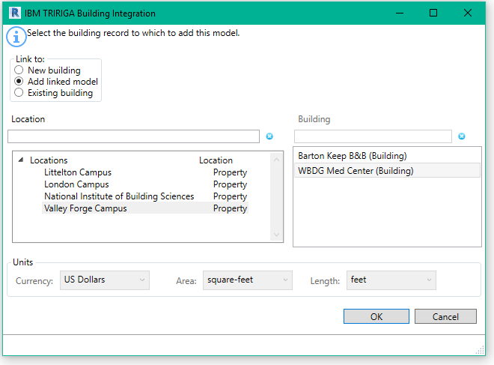

Figure 11 - Building Integration Form

To integrate the building with TRIRIGA:

1. Select how you want to integrate the building. The behavior of the rest of the form varies slightly based on the option selected.
2. Select a location. The location list can be filtered if desired.
3. If “Add Linked Model”, or “Existing Building” is selected, the building list is populated with buildings available for the location. The list is retrieved from the TRIRIGA server when the location is selected, so large lists may take a moment to load. For “Existing Building”, all buildings for the location are displayed. For “Add Linked Model”, only building, that were previously linked to a model through one of the other two options are displayed.
4. If “New Building” is selected, you can specify currency and units of measure.

**Validation:** When the form is opened, the following validations are performed on the list of levels:

* Project Information: IBM.BuildingName, and the IBM.ModelName parameters have values
* Project Information: IBM.BuildingName, and the IBM.ModelName don’t contain the # character
* Project Information: IBM.BuildingName, and the IBM.ModelName don’t exceed 150 characters in length

**Update**: If “Existing Building” is selected, in the Project Information object:

* The IBM.Name is updated from the TRIRIGA building name
* The IBM.Description is updated from the TRIRIGA building description.
* The Connector GUID for the model is updated from the TRIRIGA building record

Once a model is integrated with TRIRIGA, the building tool is inactive. To integrate the model with a different TRIRIGA server, or to create a second instance of the building on the same server, the model must first be detached from TRIRIGA which clears all data used by the connector.

### Levels

The Levels tool can be used to: create TRIRIGA Floors from Revit Levels, to link Revit Levels to existing TRIRIGA floors, or to link Levels from linked model files to Floors created from the same Level in the primary model file.

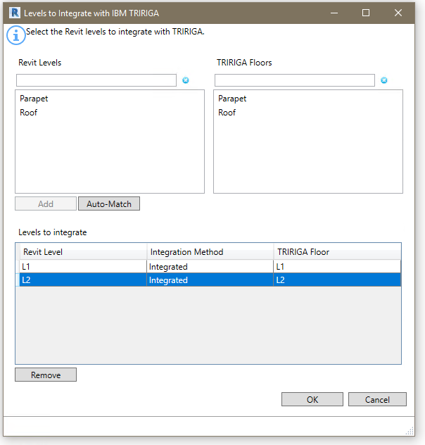

Figure 12 - Levels Integration Form

**Revit Levels:** All the level in the model which are not yet integrated.

**TRIRIGA Floors:** If the building integration process used the “Existing Building” or the “Add Linked Model” option and the TRIRIGA building has existing floors, then the list of Floors which are not integrated with a level is displayed.

**Levels to Integrate:** This shows all level that have been selected for integration or are already integrated. If they are already integrated, the associated TRRIGA Floor is shown in the TRIRIGA Floor column. If processing this form will create a new Floor, New is shown. The Integration Method Column may have one any of:

* Blank: The level is not currently associated with a TRIRIGA Floor, and the process will create a new TRIRIGA floor and link the level to the new floor.
* Integrated: The indicated TRIRIGA Floor was previously created from this level and this model file. Or, that an existing TRIRIGA floor was selected that was not created from a model. The integration process will update the TRIRIGA floor to associate it with the Level.
* Linked: The indicated floor was previously created from a different model file that is part of the linked model set, and is either already linked to the Level in this model, or will be linked to the Level when the integration process runs.
* Locked: With Linked model files, in some cases Revit gives the Levels in the linked model file the same ID as the Level in the primary model file. The connector detects this and automatically associates the levels and marks them as “locked” because the association cannot be edited.

When the form is displayed, it attempts to match Revit Levels to TRIRIGA Floors by GUID. All matches are moved to the Levels to Integrate table. However, the form still needs to be processed to write these matches into the model. Typically, there are matches if the Floors were originally created from this model, the model has been detached, and is being re-integrated.

**Add:** If one or more level is selected, the Add button is active. Pressing Add moves all the selected levels from the Revit Levels list to the Levels to Integrate table and shows an action of New.

If a single item is selected in the Revit Levels list, and an item is then selected in the TRIRIGA Floors list, they are linked, removed from their respective list and added to the Levels to Integrate list:

* If the Floor was either not created by the Connector, or was previously created from this model file, the integration method is “Integrated”.
* If the Floor was created from a different model file in the linked set. the integration method is “Linked”

**Auto-Match:** Auto-match attempts to match Revit Levels to TRIRIGA floors by matching the IBM.Name value to the Floor name. Each match is processed as above.

**Remove:** Removes the selected Level(s) from the integration list, When the form is processed, if it was previously integrated, the triBIM staging record is delete in TRIRIGA, if it was previously linked, the link is clear in Revit.

When the form is initially loaded, it tries to match Revit Levels to TRIRIGA Floors based on the GUID. If the model was previously detached, and is being re-integrated, all levels previously created from the model match and are moved to the Levels to Integrate table.

**Validate:** When the form is opened, the following validations are performed on the list of levels:

* All levels have a value in their IBM.Name parameter
* There are no duplicate values for the IBM.Name parameter in the list of levels
* The value of the IBM.Name parameter for all levels does not exceed 50 characters.

**Update:** If the level is integrated with an existing TRIRIGA Floor, the following updates are made:

* Revit Level: IBM.Name is updated from the TRIRIGA floor name
* Revit Level: IBM.Description is updated from the TRIRIGA floor description.
* Revit Level: IBM.Level is updated from the TRIRIGA Floor Level
* TRIRIGA Floor: If a gross area plan is associated with the Level, the gross area for the Floor is updated with the value calculated from the area plan by summing the area of all Areas in the Area Plan.

When the integration process runs, the following actions are performed:

* If a new integration is requested, a new triBIM Staging record is created, and a TRIRIGA floor record is created by workflow from the staging record.
* If integrate is requested, and a TRIRIGA Floor record exists, if a triBIM staging record exists on the TRIRIGA server, the staging records is updated, if not, a new staging record is created and associated with the Floor. The updates described above are performed.
* If a link is requested, The GUID of the Revit level that the floor was originally created from is retrieved from TRIRIGA and stored in a hidden parameter of the linked Level
* If the Level was previously integrated, but now is not, the triBIM staging record is deleted.
* If the Level was previously linked, but now is not, The GUID of the linked Level is removed from the Level.
* The IBM.isTRIRIGA value is updated on all Levels to reflect their new state

### Rooms

Use the Room Tool to create TRIRIGA Spaces from Revit rooms, or to link Revit Rooms to existing TRIRIGA Spaces.

|  |  |
| --- | --- |
| Tip | *Process all of the Rooms in the module you plan integrate before processing any Spaces even if you need to switch between model files. You can only link Space to Rooms, not Rooms to Spaces. So, if you create a TRIRIGA Space from a Revit Space, you will not later be able to link to a Room.* |

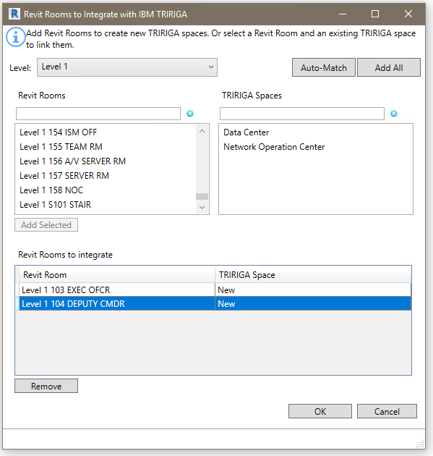

Figure 13 - Rooms Integration Form

**Levels:** The list of Levels that were integrated in the Levels step. Select the active Level. The Revit Rooms and TRIRIGA Spaces lists only contain Rooms and Spaces from the selected Level.

**Revit Rooms:** All the Rooms on the selected Level which are not yet integrated

**TRIRIGA Spaces:** If the building integration process used the “Existing Building” or the “Add Linked Model” option and the TRIRIGA building has existing Spaces, then the list of Spaces for the Floor matching the selected Level is displayed.

**Rooms to Integrate:** This shows all Rooms that have been selected for integration or are already integrated. If they are already integrated, the associated TRRIGA Space is shown in the TRIRIGA Space column. If processing this form will create a new Space, New is shown.

When the form is displayed, it attempts to match Revit Rooms to TRIRIGA Spaces by GUID. All matches are moved to the Rooms to Integrate table. However, the form still needs to be processed to write these matches into the model. Typically, there are matches if the Spaces were originally created from this model, the model has been detached, and is being re-integrated.

**Add:** If one or more Rooms are selected, the Add button is active. Pressing Add moves all the selected Rooms from the Revit Rooms list to the Rooms to Integrate table and shows an action of New.

If a single item is selected in the Revit Rooms list, and an item is then selected in the TRIRIGA Spaces list, they are linked, removed from their respective list and added to the Rooms to Integrate.

**Auto-Match:** Auto-match first attempts to match Revit Rooms to TRIRIGA Spaces by matching the IBM.Name value to the Space name. Each match is processed as above. Next it attempts to find exactly one TRIRIGA Spaces that contains the Revit Room name. Each match is processed as above. Auto-match applies to all levels.

**Add All:** Add All is a short cut for large buildings. It adds all the rooms in the Revit Rooms list for all levels to the Rooms to Integrate table.

**Remove:** Removes the selected Room(s) from the integration list, if it was previously integrated, the triBIM staging record is deleted in TRIRIGA when the form is processed.

When the form is initially loaded, it tries to match Revit Rooms to TRIRIGA Spaces based on the GUID. If the model was previously detached, and is being re-integrated, all Rooms previously created from the model match and are moved to the Rooms to Integrate table.

**Validate:** When the form is opened, the following validations are performed on the list of Rooms:

* All Rooms have a value in their IBM.Name parameter
* There are no duplicate values for the IBM.Name parameter in the list of Rooms
* The value of the IBM.Name parameter for all Rooms does not exceed 100 characters.
* All Rooms have a value for IBM.UseClassification

|  |  |
| --- | --- |
| Tip | *If the room list is empty, check the error listing. You may have forgotten to assign Use Classifications.* |

**Update:** If the Rooms is integrated with an existing TRIRIGA Space, the following updates are made:

* Revit Room: IBM.Name is updated from the TRIRIGA space name
* Revit Room: IBM.Description is updated from the TRIRIGA space description.
* Revit Room: IBM.UseClassification is updated from the TRIRIGA Use Classification
* TRIRIGA Space: If an area from a gross area plan is associated with the Space, the gross area for the Spaces is updated with the value from the associated Area. Otherwise it is updated with the area from the Revit Room.
* TRIRIGA Space: If an area from a rentable area plan is associated with the Space, the area for the Spaces is updated with the value from the associated Area. Otherwise it is updated with the area from the Revit Room.

When the integration process runs, the following actions are performed:

* If a new integration is requested, a new triBIM Staging record is created, and a TRIRIGA Space record is created by workflow from the staging record.
* If integrate is requested, and a TRIRIGA Space record exists, if a triBIM staging record exists on the TRIRIGA server, the staging the record is updated, if not, a new staging record is created and associated with the Space. The updates described above are performed by workflow.
* If the Space was previously integrated, but now is not, the triBIM staging record is deleted.
* The IBM.isTRIRIGA value is updated on all Rooms to reflect their new state

### Spaces

Use the Space Tool to associate Revit Spaces with TRIRIGA Spaces. This is typically Spaces in a MEP model file with TRIRIGA Spaces that were created from Rooms in the architectural model. This allows assets contained within Revit Spaces to be associated with the correct TRIRIGA Space. You may also use this tool to create new TRIRIGA Spaces just like the Room Tool.

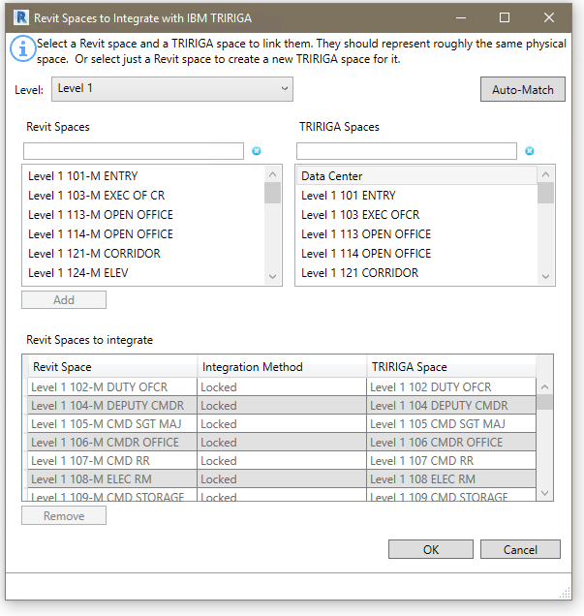

Figure 14 - Space Integration Form

When this form is displayed, it reflects the current state of the model, except where it makes automatic matches. The form must still be processed for the automatic matches to be written into the model.

**Levels:** The list of Levels that were integrated in the Levels step. Select the active Level. The Revit Spaces and TRIRIGA Spaces lists only contain Spaces from the selected Level.

**Revit Spaces:** All the Spaces on the selected Level which are not yet integrated

**TRIRIGA Spaces:** All of the TRIRIGA. Spaces for the selected Level that are not yet integrated. Typically, these Spaces were created from Rooms in a linked model file that was previously integrated, and the current model file is integrated as a Linked Model.

**Revit Spaces to Integrate:** This shows all Spaces that have been selected for integration or are already integrated. If they are already integrated, the associated TRRIGA Space is shown in the TRIRIGA Space column. If processing this form will create a new Space, New is shown. The Integration Method Column may have one any of:

* Blank: The Space is not currently associated with a TRIRIGA Space, and the process will create a new TRIRIGA Space and link the Revit and TRIRIGA Spaces.
* Integrated: The indicated TRIRIGA Space was previously created from this Space and this model file. Or, an existing TRIRIGA Space was selected that was not created from a model. The integration process will update the TRIRIGA Space to associate it with the Revit Space.
* Linked: The indicated Space was previously created from a different model file that is part of the linked model set, and is either already linked to the Space in this model, or will be linked to the Space when the integration process runs.
* Locked: If Rooms and Spaces exist in the same model file, and share the same boundary, Revit recognizes that they describe the same space and links them. The connector recognizes this, automatically matches them and shows the integration method as “Locked”

**Add:** If one or more Revit Spaces are selected, the Add button is active. Pressing Add moves all the selected Spaces from the Revit Spaces list to the Spaces to Integrate table and shows an action of New.

If a single item is selected in the Revit Spaces list, and an item is then selected in the TRIRIGA Spaces list, they are linked, removed from their respective list and added to the Spaces to Integrate table.

**Auto-Match:** Auto-match first attempts to match Revit Rooms to TRIRIGA Spaces by matching the IBM.Name value to the Space name. Each match is processed as above. Next it attempts to find exactly one TRIRIGA Space the contains the Revit Room name. Each match is processed as above. Auto-match applies to all levels.

**Remove:** Removes the selected Space(s) from the integration list, if it was previously integrated, the triBIM staging record is deleted in TRIRIGA when the form is processed.

When the form is initially loaded, it tries to match Revit Rooms to TRIRIGA Spaces based on the GUID. If the model was previously detached, and is being re-integrated, all Spaces previously created from the model match and are moved to the Spaces to Integrate table.

**Validate:** When the form is opened, the following validations are performed on the list of Revit Spaces:

* All Spaces have a value in their IBM.Name parameter
* There are no duplicate values for the IBM.Name parameter in the list of Spaces
* The value of the IBM.Name parameter for all Spaces does not exceed 100 characters.
* All Spaces have a value for IBM.UseClassification

|  |  |
| --- | --- |
| Tip | *If the Space list is empty, check the error listing. You may have forgotten to assign Space Use Classifications.* |

**Update:** If the Space is integrated with an existing TRIRIGA Space, the following updates are made:

* Revit Space: IBM.Name is updated from the TRIRIGA space name
* Revit Space: IBM.Description is updated from the TRIRIGA space description.
* Revit Space: IBM.UseClassification is updated from the TRIRIGA Use Classification

When the integration process runs, the following actions are performed:

* If a new integration is requested, a new triBIM Staging record is created, and a TRIRIGA Space record is created by workflow from the staging record.
* If integrate is requested, and a TRIRIGA Space record exists, if a triBIM staging record exists on the TRIRIGA server, the staging records is updated, if not, a new staging record is created and associated with the Space. The updates describe above are performed.
* If a link is requested, the GUID of the Revit Room that the space was originally created from is retrieved from TRIRIGA and stored in a hidden parameter of the linked Space
* If the Space was previously integrated, but now is not, the triBIM staging record is deleted.
* If the Space was previously linked, but now is not, The GUID of the linked Room is removed from the Space.
* The IBM.isTRIRIGA value is updated on all Spaces to reflect their new state

### Assets

Use the Asset Tool to create TRIRIGA BuildingEquipment records from Revit Components. The following categories of components can be integrated:

* Air Terminals
* Data Devices
* Doors
* Duct Fittings
* Electrical Equipment
* Furniture
* Lighting Devices
* Lighting Fixtures
* Mechanical Equipment
* Pipe Accessories
* Plumbing Fixtures
* Specialty Equipment
* Telephone Devices

#### Match to Existing Asset

Before creating a new asset, the connector attempts to match each asset to an existing TRIRIGA BuildingEquipment record. First it attempts to match the Revit Component ID to an ID in a triBIM staging record. This is useful If the building is being re-integrated, Second, it tries to match the IBM.BarCode parameter value to the barcode of existing BuildingEquipment records. If a match is found, the asset is linked to the existing record.

#### Match to Specification

All TRIRIGA BuildingEquipment records must be associated with a BuildingEquipment specification. Specification records are not created by the connector so must exist before the asset integration process is run.

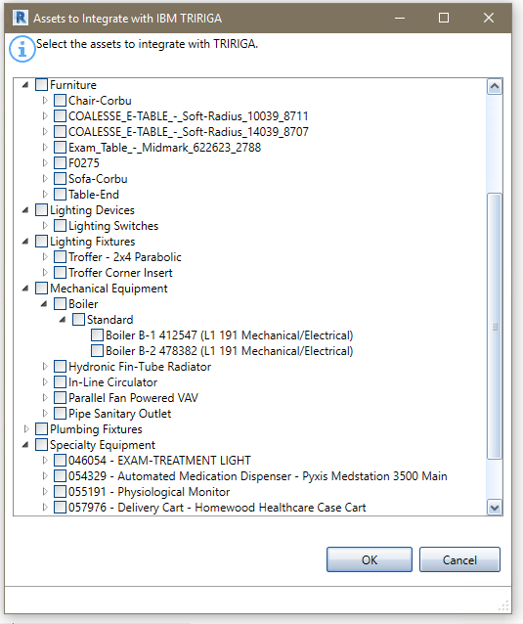

Figure 15 - Asset Integration Form

The Asset listing is filtered by previous integration choices. If an asset is on a level, it is only shown if the level is integrated, if the asset is contained in a Room or a Space, it is only shown if the containing Room or Space is integrated.

When the form is initially displayed, the currently integrated items are checked.

Check items are to be integrated when the form is processed.

**Validate:** When the form is opened, the following validations are performed on the list of Revit Components:

* All Components have a value in their IBM.Name parameter
* There are no duplicate values for the IBM.Name parameter in the list of Components
* The value of the IBM.Name parameter for all Components does not exceed 100 characters.
* All Components have a value in their IBM.BarCode parameter
* There are no duplicate values for the IBM.BarCode parameter in the list of Components

**Update:** If the Space is integrated with an existing TRIRIGA Space, the following updates are made:

* Revit Component: IBM.Name is updated from the TRIRIGA asset name
* Revit Component: IBM.Description is updated from the TRIRIGA asset description.

When the integration process runs, the following actions are performed:

* If a new integration is requested, and no triBIM staging record exists, a new one is created. Otherwise it is updated.
* If no TRIRIGA asset BuildingEquipment record is associated with the staging record, the publish workflow attempts to find a match by searching for a record with the same barcode. If it finds exactly one, it is associated with the staging record
* If no match is found, the workflow that attempts to find a BuildingEquipment specification.
  + It first searches for a specification with a name that matches the IBM.Name of the Revit Type of the Component. This is the value that was generated during the populate parameters process from the Specification Name generation rule configured in Project Settings.
  + If no match is found, it next searches for a specification with a name that matches the Revit category (one of the above values) of the Component.
  + If no match is found, an error message is recorded and no BuildigEquipment record is created.
  + If a match is found, a new BuildingEquipment record is created and associated with the triBIM staging record, the specification. The location is set to the space, floor, or building as provided in the location path.
* If the Component was previously integrated, but now is not, the triBIM staging record is deleted.
* The IBM.isTRIRIGA value is updated on all Components to reflect their new state

### Detach

Detach removes **ALL** data added to the model by the connector, including deleting all shared parameters used by the connector and all project settings.

It also clears the unique ID assigned to the model by the connector. For models that were integrated as a new or existing building, this can be reestablished by integrating the model again to the same server using the existing building option. For models that were integrated using the Linked Model options**, there is no way to recover this**

## Update

### Sync

Use the Sync tool to synchronize a limited number of Floor and Space properties between Revit and TRIRIGA.

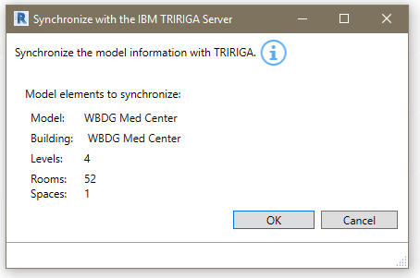

Figure 16 - Synchronize with TRIRIGA Form

There is no user input for Sync.

**Update:** For Levels that are integrated with TRIRIGA Floors, the following updates are made:

* Revit Level: IBM.Name is updated from the TRIRIGA floor name
* Revit Level: IBM.Description is updated from the TRIRIGA floor description.
* Revit Level: IBM.Level is updated from the TRIRIGA Floor Level
* TRIRIGA Floor: If a gross area plan is associated with the Level, the gross area for the Floor is updated with the value calculated from the area plan by summing the area of all Areas in the Area Plan.

For Rooms and Spaces that are integrated with existing TRIRIGA Spaces, the following updates are made

* Revit Room or Space: IBM.Name is updated from the TRIRIGA space name
* Revit Room or Space: IBM.Description is updated from the TRIRIGA space description.
* Revit Room or Space: IBM.UseClassification is updated from the TRIRIGA Use Classification
* TRIRIGA Space: If an area from a gross area plan is associated with the Space, the gross area for the Space is updated with the value from the associated Area. Otherwise it is updated with the area from the Revit Room.
* TRIRIGA Space: If an area from rentable area plan is associated with the Space, the area for the Spaces is updated with the value from the associated Area. Otherwise it is updated with the area from the Revit Room.

### Publish Floor Plans

Use the Publish Floorplan Tool to publish one or more floorplans for use in the TRIRIGA graphics section, and the Floorplan tab in the Locate and Work Task applications.

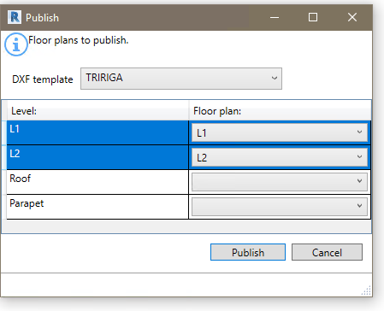

Figure 17 - Publish Floorplan Form

When this form is first displayed, it shows the options used in the last publish operation.

The Publish Floorplan tool uses the Revit DXF export feature to export the selected floorplans in DFX format. Each DXF file is then imported into TRIRIGA and rooms on the floorplan are automatically associated with TRIRIGA spaces created by the connector.

The DFX files are saved in:

<UsrProfile>\AppData\Local\IBM\TRIRIGA\AR Integrator\Drawings.

**DXF Template**: Revit uses DXF templates to control many visual aspects of a floorplan exported in DXF format. The dropdown shows all the DXF templates included in the model. If one is selected, it is applied to all of the selected floorplans.

Select the table rows for the Levels for which you want to publish floorplans.

The Floor plan dropdown on each row has a list of floorplans in the model for that level. Select the desired plan.

### Publish Model

Publish the current Revit file to the Forge service, submit if for translation, and associate it with the building record created from the connector.

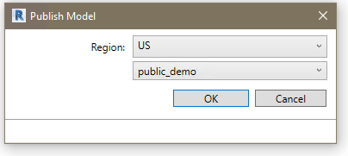  
Figure 18 - Publish Model Form

**Region.** Selects the geographic region where the uploaded model and resulting translated viewable will be physical stored. This filters the bucket list for bucked within the region.

**Forge service access is proxied through TRIRIGA.** It uses the Forge application credentials configured in TRIRIGA and TRIRIGA security is applied.

## Open in TRIRIGA

Each tool in this section launches the TRIRIGA application in the default browser using the credentials and server definition used for the connector login.

### Open Building

The tool opens the building record associated with the model.

### Open Selection

The opens a single Floor or Space in TRIRIGA based on the Revit selection. The tool is only active if there are items selected and only functions if the selection is either a single Level or a single Room.

### Launch Portal

This tool launches the main TRIRIGA portal

## Help

### Info

This tool displays connector version and build information

# Autodesk Forge Model Administration

Model administration is performed from the BIM Administration Tool which is found in the TRIRIGA portal under Tools. Typically, the model must be prepared using Autodesk Revit® and Navisworks®. To utilize the Autodesk Forge viewer, models must be uploaded to the Forge service, and translated to the format used by the viewer. The viewable format must then be associated with the TRIRIGA building record that corresponds with the model.

Figure 19 depicts the process for configuring the Forge viewer for use in TRIRIGA and for managing models.



Figure 19 - Model Integration Process

## Setting up the Forge Service

These steps are performed once when the Autodesk Forge service is first registered with TRIRIGA, and may be revisited if there are changes in your Autodesk Forge account.

### Register with Autodesk Forge and Create an application

The Forge Viewer and Forge Service are Autodesk® products integrated with TRIRIGA. Use of the Forge service requires a subscription from Autodesk. A new subscription or a free trial may be secured here:

<https://developer.autodesk.com/>

Or an existing Autodesk account may be used.



Figure 20 – Create an Autodesk® Forge application

Once you have registered for the service, Select Create Application to Create a Forge application for use with TRIRIGA. A single application can be shared between multiple instances of TRIRIGA or between TRIRIGA and Maximo. However, TRIRIGA does not support BIM360 logins.

The Data Management API and Model Derivative APIs are required

None of the values entered in this screen are visible from within TRIRIGA. Select values that will help you identify this application should you need to return to this screen. TRIRIGA does not support 3 leg authentication, so the callback URL is not used. Enter any value that is a valid URL format.



Figure 21 – Forge application definitions

Once the application is created, the application credentials are displayed (the yellow highlighted fields). **Keep these secure**, as they allow access to all date and functions of the application. This will include all the models that you use in TRIRIGA. If they are compromised, you can return to this page to generate a new secret which must then be updated in TRIRIGA.



Figure 22 – Forge application credentials

### Entering Forge Credentials into TRIRIGA

To utilize Forge services from within TRIRIGA, the credentials created in the previous step must be registered with TRIRIGA. All administration of the Forge service from within TRIRIGA, as well as model management is done with the BIM Model Management Tool found under Tools on the TRIRIGA portal.

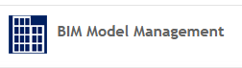

1. From the BIM Model Management Tool menu, select “Set Key System Wide”. This displays a dialog to enter the Forge Credentials
2. Enter the credentials from the application you created in the previous step.
3. When the dialog is accepted, a warning message is displayed. If this is the first time you are entering credentials, or you are only updating the client secret, this can be ignored.

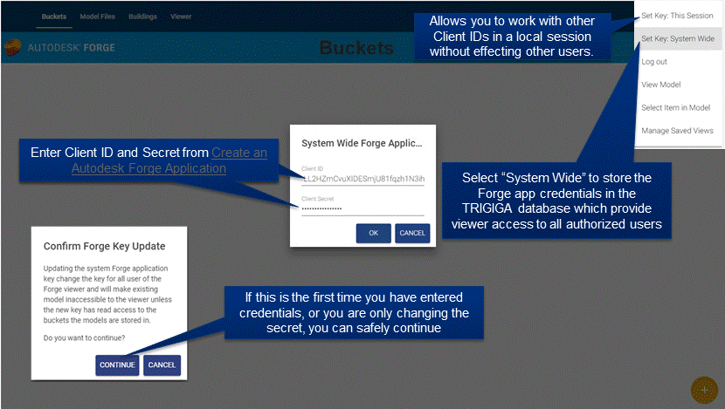

Figure 23 – Configure Forge Credentials in TRIRIGA

If you need to work with other Forge applications, credentials can be set for your login without affecting other users by selecting “Set Key: This Session”. Be sure to explicitly logout when you are done to clear your credentials. When switching credentials, the first access to the viewer fails. This forces a credential reset and subsequent access succeeds.

### Configure TRIRIGA for access to Forge Management tool

When the Forge service is accessed through TRIRIGA, normal TRIRIGA security controls which users can access Forge service operations. The BIM User security group is pre-configured for full access to the Forge Service.

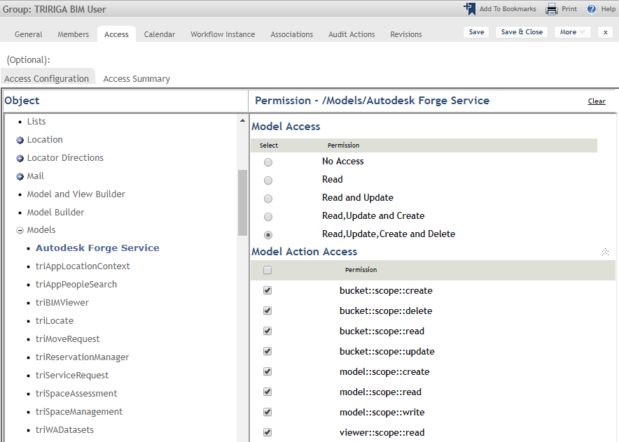

Figure 24 – TRIRIGA BIM User Security Group.

Fined-grained access is controlled through the Autodesk Forge Service model. Model actions are mapped directly to the scope parameter of the Forge Authenticate endpoint defined here:

<https://developer.autodesk.com/en/docs/oauth/v2/overview/scopes/>

Viewer::scope::read is required for any user that access the Forge viewer. It may be desirable to add this access to other security groups.

### Autodesk SSL Certificate

For TRIRIGA to access the Autodesk Forge service, the app server must make an SSL connection to the Autodesk cloud services. This requires the app server to trust the Forge SSL Certificate. Typically, Java Virtual Machines (JVMs) browsers and app servers include the signer certificate from most major certificate authorities so they trust any certificated signed by these certificate authorities including those used by the Forge service. However, high security app server deployments don’t include any certificate authority certificates in the app server trust store as part of the base install. This means that the app server doesn’t trust the Autodesk certificates and connections to the Forge service fail with an SSL Handshake exception. To resolve this, the certificate authority public root certificate use for by the Forge service must be imported into the app server trust store.

There has been some variance seen in the certificate presented by the Forge service both over time and by region, so these steps may need to be periodically repeated.

The procedure varies by app server

#### WebSphere®

The certificate can be imported from the WebSphere admin console.

* Select Security->SSL certificate and key management
* From “Related Items”, select: Key stores and certificates
* Select NodeDefaultTrustStore if available. Otherwise select CellDefaultTrustStore
* From “Additional Properties” Select Signer certificates
* Select “Retrieve from port”
* Provide the following values:

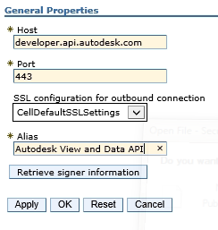

Select “Retrieve signer information”

WebSphere should respond with:

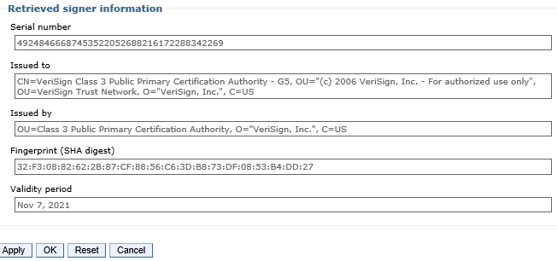

* Click OK, and the save the changes on the following screens.

Note: The certificate may not match what is shown above.

#### WebSphere Liberty

WebSphere Liberty relies on the underling JVM trust store. The following is one of many ways the Forge signer certificate can be retrieved and imported into the JVM trust store.

**To retrieve the certificate:**

Open the link <https://developer.api.autodesk.com> in FireFox

Click on the certificate (next to the site name)

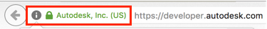

* Click the “>” button

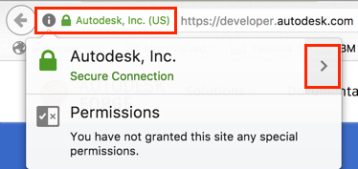

* Click on “More Information”
* Click on "View certificate"
* Click on "Details"
* Click on "Export..."
* Choose "X.509 Certificate **with chain** (PEM)", select the folder and name (e.g., *developerapiautodeskcom.crt*) to save it and click "Save"

To add the certificate to the JVM trust store

* Open a command prompt.
* Navigate to the bin directory of the JVM used by WebSphere Liberty. Liberty locates JVM by testing the following:
  + JAVA_HOME environment variable
  + JRE_HOME environment variable
  + Looking for a JVM in the path
* Use the keytool to import the certificate.   
    
  The following is a sample command line for Windows:

keytool -importcert -alias developerautodeskcom -keystore "C:\Program Files\Java\jdk1.8.0_162\jre\lib\security\cacerts" -file C:\temp\developerapiautodeskcom.crt

The following is a sample command line for Mac OS:

sudo keytool -import -alias developerautodeskcom -keystore /Library/Java/JavaVirtualMachines/jdk1.8.0_161.jdk/Contents/Home/jre/lib/security/cacerts -file ~/Desktop/developerautodeskcom.crt

sudo password: <your log in password>

keystore password: changeit

* When prompted, the default password is changeit, or whatever you have set you keystore password to.

The above command lines are for the Oracle® JVM. They differ slightly for the IBM JVM.

## Exporting Navisworks Models

Forge viewer viewable objects created directly from Revit models have no visual representation for Revit Rooms and Spaces. This means they cannot be used to visualize TRIRIGA spaces, severally limiting their usefulness. This can be resolved by using Navisworks models. To do that, the Revit model needs to be converted to Navisworks. There are two ways to do that:

* Directly open the Revit file in Navisworks
* Use the Navisworks exporter plug-in for Revit.

### Exporting the model

The plug-in appears to produce better files, and can be used without a Navisworks license, so it is what is covered here. The exporter can be downloaded [here](https://www.autodesk.com/products/navisworks/3d-viewers)

The exporter is found on the Revit add-in ribbon



There are several export options that may be useful. These are accessed from the file selection dialog after export is selected.



If you don’t have a Navisworks license, you should select “Convert Linked Files” as this is the only way to get a single Navisworks file that contains all of the model. If you do have a Navisworks license, you can gain more control by exporting each file separately and merging them in Navisworks.



### Enhancing the model

If you have a Navisworks license, there are several things you can do to improve the usefulness of the model in TRIRIGA:

**Merging Files:** You can add linked files to the Navisworks model by selecting:

**Home-**>Append

**Setting the Default View:**  The Forge translation service uses the default view. This is what is displayed when you initially open the file, and is set by what is displayed when you save the view.

**Changing element visualization:** There are several ways the visual aspect of elements can be customized all of which require locating and selecting all instance of the item. One way of doing this is with the Selection Tree. Navigate to the desired item set, and right click to see a list of options. One useful approach is to use Revit Categories. These can be found at:

**Element-**>Category->Name

**Suggested enhancements including**

* Decreasing the transparency and changing the color of rooms
* Hiding all spaces except those explicitly integrated with TRIRIGA, for those that are integrated, setting the transparency and color to match Rooms
* Color coding key assets or color-coding asset by category

## Importing models into the Forge Service

There are 4 steps required to view a model with the Forge Viewer from within TRIRIGA:

1. Create one or more storage containers called Buckets in the Forge service to hold the model files. For the purpose of a demo, only one storage container is required. If you manage models for multiple projects or companies, you should create additional container to organize you models.
2. Uploaded the model files(s) to the Forge service.
3. Request that the Forge service translate the model into a viewable format.
4. Associate the viewable model with the TRIRIGA Building record for the facility that is represented by the model. The Building and its contained Floor, Space, and BuildingEquipment records are typically created from Autodesk Revit with the TRIRIGA Connector for BIM.

Some of the above steps may have been performed outside the current TRIRIGA instance. If so, Buckets, Model Files and translated models may already be shown in the BIM Model Administration tool.

### Managing Model Storage

The Forge service uses storage containers (called buckets by Forge) to store any model files that are uploaded to the service. A storage container is similar to a directory in a file system. Buckets are managed from the Bucket tab of the BIM Model Administration tool.

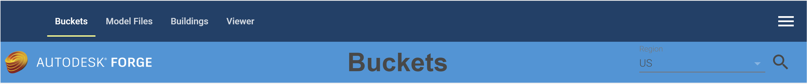

When the Bucket tab is displayed, existing buckets are automatically displayed. Buckets are filtered by region. US is the default region. To view Buckets for a different region, select the region from the Region drop down and click the Search icon.

#### Creating a storage container:

To use the Forge service, you must create at least one storage container. To create a storage container,

1. Select the  icon to display the Create Bucket dialog

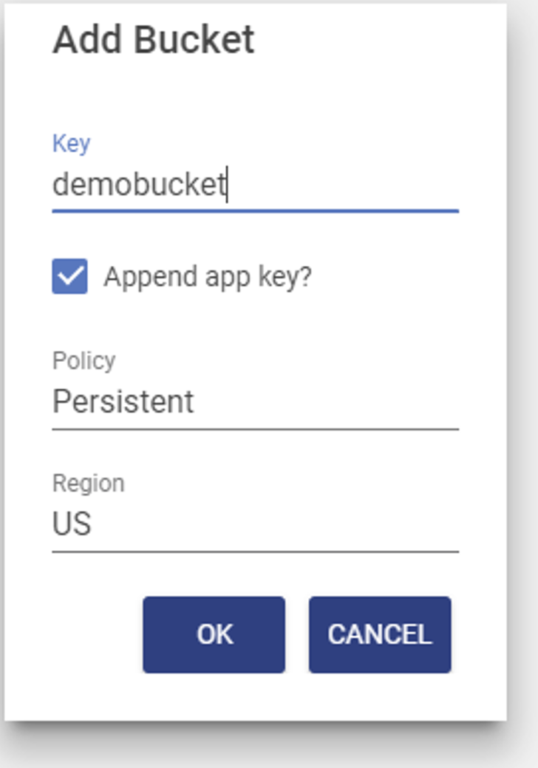

1. Specify a storage container name and description**.** Names must be unique across the Autodesk Forge service including all Autodesk Forge users. To facilitate this, TRIRIGA can append your Autodesk Forge service key to your storage container name. If you select this option, only the base name is displayed on the UI. If you don’t select this option, it is highly recommended that you include in your storage container names some unique string that is associated with your company or organization, such as a registered domain name,

Unless you design your own strategy to ensure your storage names are unique across the entire Forge Service, you should leave the Append Service key checkbox checked.

The name may contain -_.a-z0-9 and must be between 3-128 characters in length including the appended key.

1. Select the desired retention policy. There are three types of buckets:

**Transient:** Model files are retained only for 24 hours

**Temporary:** Model files are retained only for 30 days

**Permanent:** Model files are retained until they are deleted.

**Note:** If a model has been translated to a viewable format and is then removed, including through its storage period expiring, the viewable format is not removed.

1. The region displayed here is read only. It is set by the dropdown on the toolbar**.** That is, buckets are always created from the actively displayed region. Buckets may be created in the US or the EMEA region of the Forge service. The region controls the physical location of the Forge service servers that host the Bucket.

#### Deleting a Storage Container:

A storage container can be deleted. Deleting a storage container also deletes everything that is stored in it**. This process CANNOT be undone**. All models and translated viewable bubbles stored in the container are also deleted. To delete a Bucket:

1. From the Bucket tile, click the “Delete Permanently” icon



1. This displays the delete confirmation dialog. **Heed this warning.** You can delete a very large amount of data with a few mouse clicks!

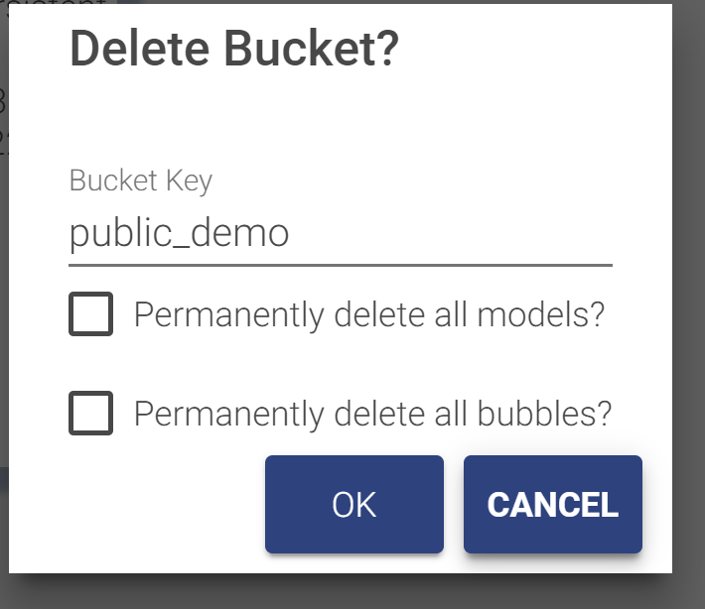

1. Check both the “Permanently delete all models” and the Permanently delete all bubbles” check boxes. You cannot accept this dialog until you have acknowledged that all the data in the bucket will also be deleted.

#### Rights

Rights to a storage container may be granted to other service keys. The actions Autodesk currently allows through granted rights is extremely limited so it is currently of little use.

To grant rights:

1. On the tile for the bucket: select the lock icon, this displays the rights dialog

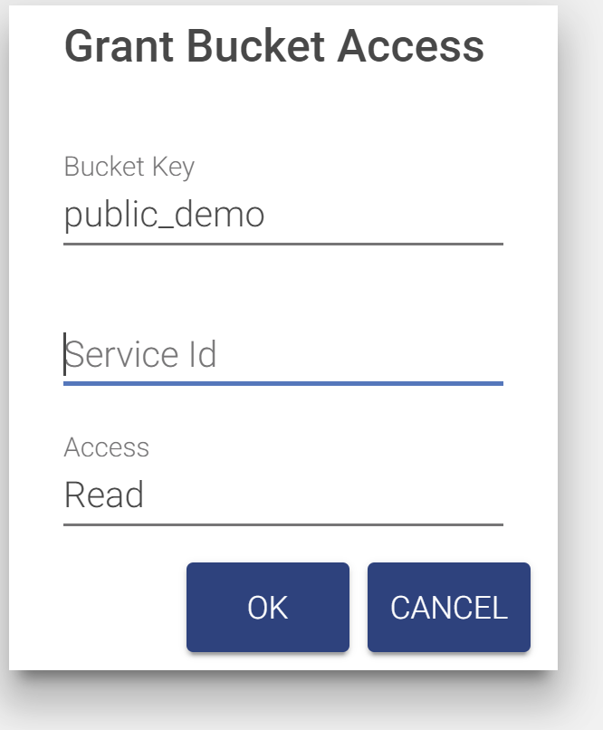

1. Enter the Service ID for any other Forge application
2. Select the rights to grant.
3. The bucket tile displays a list of all service ids that have access to the bucket

There is no validation that the service id is valid.

To remove access, click the trash can to delete the row. The row is deleted immediately.

### Managing Model Files

Model files are managed from the Model tab of the BIM Model Management tool

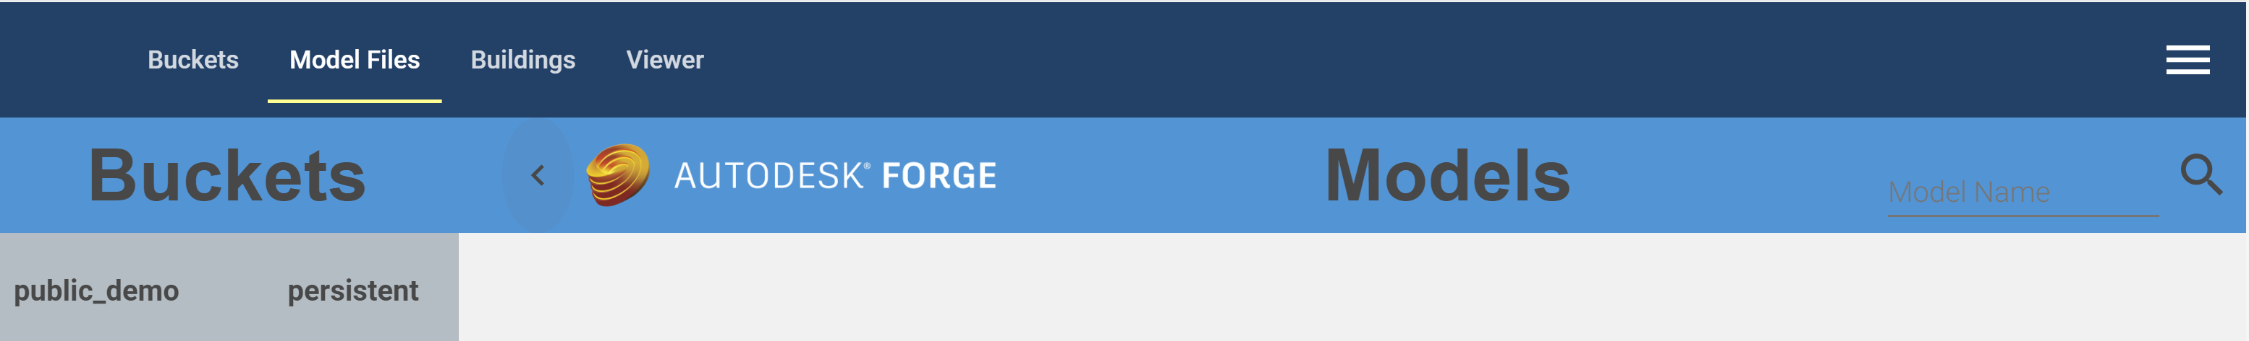

The tab has a fly-out on the left that displays the list of buckets from the Bucket tab, and a list of models contained in the selected bucket.

* When the tab is first displayed, the first bucket in the list is selected, and the first 50 models in the bucket are displayed. Autodesk does not guarantee any sort order so it is effectively 50 random models.
* Additional models may be displayed by scrolling to the bottom of the model list.
* The model list may be filtered by entering a value in the model name field on the tool bar and clicking the search icon. Models whose name begin with the search string are listed. The search is case sensitive.
* Selecting a new bucket updates the model list using the current search criteria.

Any type of file can be uploaded to a bucket. However, only those file types that can be translated into viewable format are of interest here. Each model file is displayed as a tile. The content of the tile varies during the model upload and translation process (see below). A fully translated model ready for use displays a thumbnail image of the model and a link to drill into details of the model.

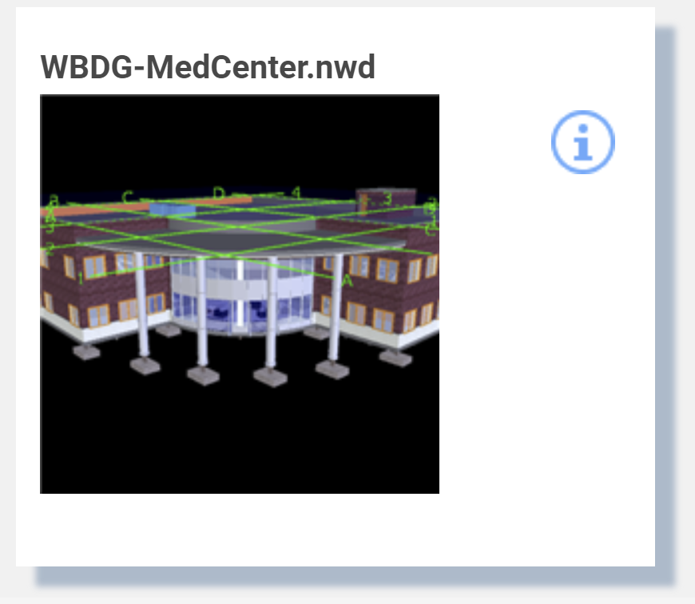

Selecting the thumbnail switches to the viewer tab and displays the model in the viewer. Selecting the info icon drills into details of the model (see below).

### Upload Model

1. To upload a model file, click the Upload Model button 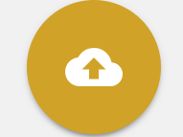.. This displays the Upload Model dialog. The model is uploaded into the currently active bucket.

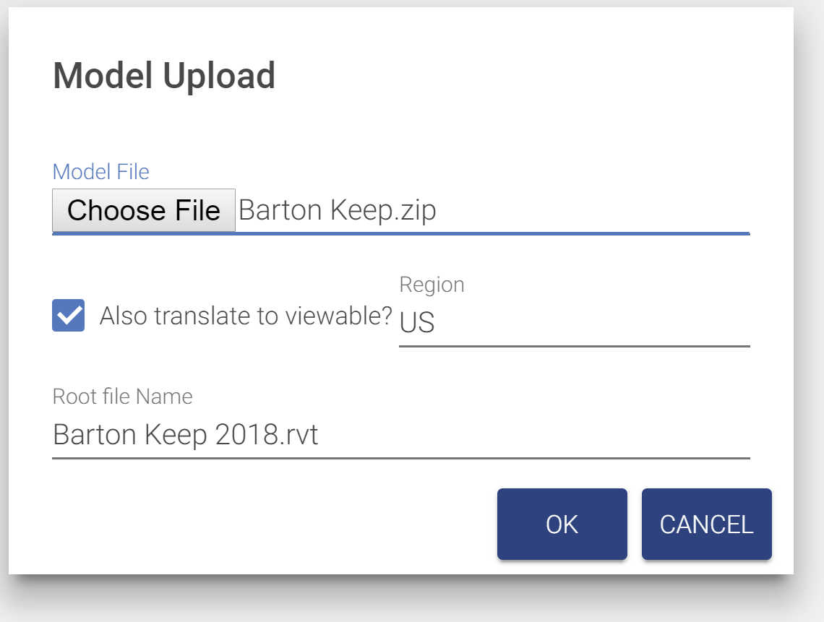

Figure 25 - Model Upload

1. Select a model file to upload.
2. Checking the Also Register Viewable checkbox causes the model to be automatically submitted to the Forge Service for translation and eliminates the need to manually perform the viewable translation process.
   1. Select a region. This is where the translated viewable “bubble” will reside. This may be different from the bucket containing the model.
   2. If the model file is a zip archive containing a set of linked files (see below), specify the base file name with extension of the root file. This is the file that you would normally open to view the model set.
3. Click OK and you are returned to the Models tab. A tile is added for the new model as the first tab in the model list. If the model list is refreshed while an upload is in progress, the monitoring tile is lost, but if the upload is successful, a normal model tile is available for display when it is complete.

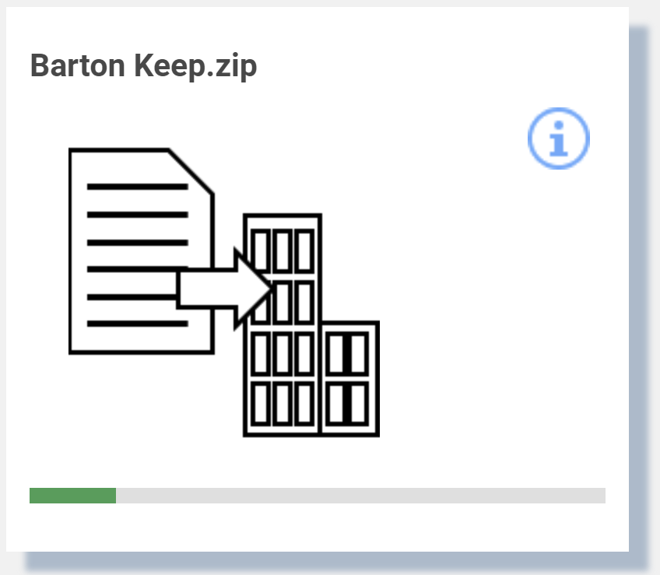

1. If “Also translate to viewable” is selected, when the upload is complete, the translation process is started. This may take a few seconds to several hours. The tile displays the progress of the translation process. Initially, the translation progress is updated every 30 seconds. After a few minutes, the update is less frequent. The translation process may be manually displayed and updated from the Bubble tab of the model details dialog (see below). If the model list is refreshed during the translation process, the tile is displayed in its normal position in the list instead of first and the progress monitoring is halted. Progress can still be manually displayed.

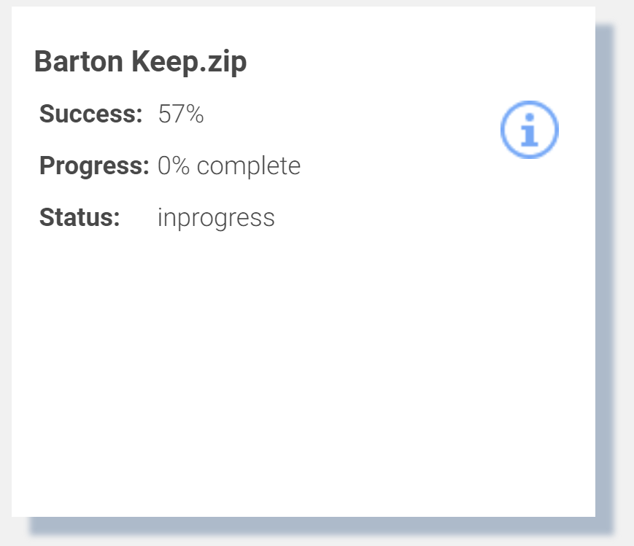

#### Translating models

The model translation process may be run separately from the model upload. A model that has been uploaded but not translated has the following tile:

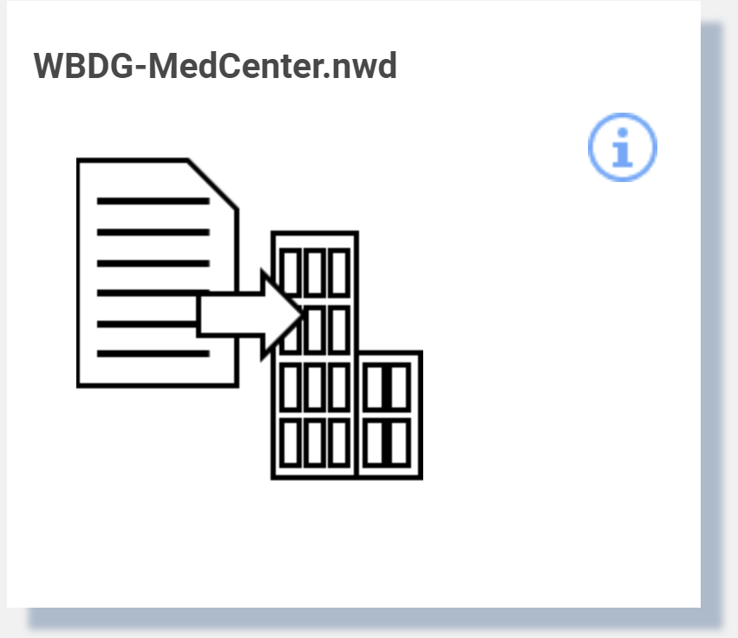

Clicking the image displays the Model Translation dialog

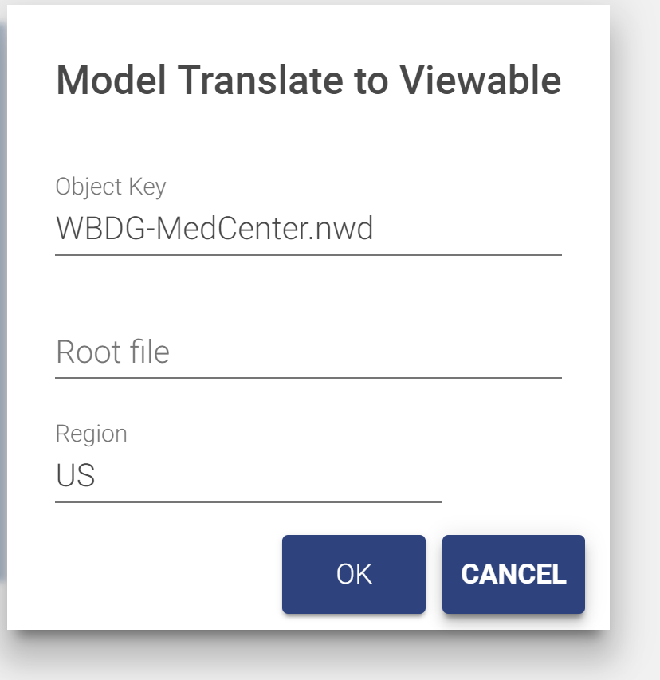

1. Select a region. This is where the translated viewable “bubble” will reside. This may be different from the bucket containing the model.
2. If the model file is a zip archive containing a set of linked files (see below), specify the base file name with extension as the root file. This is the file that you would normally open to view the model set.

The translation process may take a few seconds to several hours. The tile displays the progress of the translation process. Initially, the translation progress is updated every 30 seconds. After a few minutes, the update is less frequent. The translation process may be manually displayed and updated from the Bubble tab of the model details dialog (see below). If the model list is refreshed during the translation process, progress monitoring is halted. Progress can still be manually displayed.

#### Working with multi-file models

Some modeling tools such as Revit have workflows that distribute a model across many files that are then linked to form the complete model. For example, a model may be divided into an architectural, and MEP, and a structure component each in different Revit files. The Forge service can integrate these parts into a single model for display in the Forge viewer. To do so, perform the following steps:

1. Gather the files composing the model into a directory tree that can easily be converted into a .zip file. Ideally you should remove extraneous files such as auto-save files.
2. Select the file that will be the master file for the linked model. Ensure that all linked parts or sub-model files load correctly when this file is opened.
3. Convert the directory containing the model files into a .zip archive.
4. Upload the .zip archive as described above.

#### Model Details

The provides a drill down into additional information about the model file and about any translated viewable data which Autodesk refers to as the “Bubble”. The information varies by type of file.

If the model is in the process of translation, or translation has been attempted whether or not it succeeded, the dialog has a Bubble tab that includes the status of the translation process.



Figure 26 - Translated Viewable (bubble) Details

**Has Thumbnail:** Indicates if the bubble included a thumbnail image of the model. Revit, Navisworks, and AutoCAD file all have a thumbnail.

**Started At:** Timestamp of when the model was submitted for translation

**Progress:** Percent of the translation process that has completed.

**Success:** Percent of the model that has been successfully translated

**Status:** Status of the translation process. Typically, In Progress, Success, or Failed

**Fetch Time:** When the information in the dialog was last refreshed

Use the Refresh button to update the dialog with the current values directly from the Forge Service.

Other information on the bubble tab, and the information on the mode tab is only useful to administrators that have other interactions with the Forge service.

The bubble for Revit files includes information from the Revit Project Information screen. Translated Revit files have a Project Information tab with this information

#### Delete Model

A translated model consists of several Forge objects: the model files and a set of objects that constitute the bubble. The model files and the bubble can be deleted independently of each other.

* To delete the model with an option to also delete the bubble:
  + Open the Model detail dialog as above
  + From the Model tab, click the trash can (Permanent Delete) icon
  + A confirmation dialog is displayed with an option to also delete the bubble.

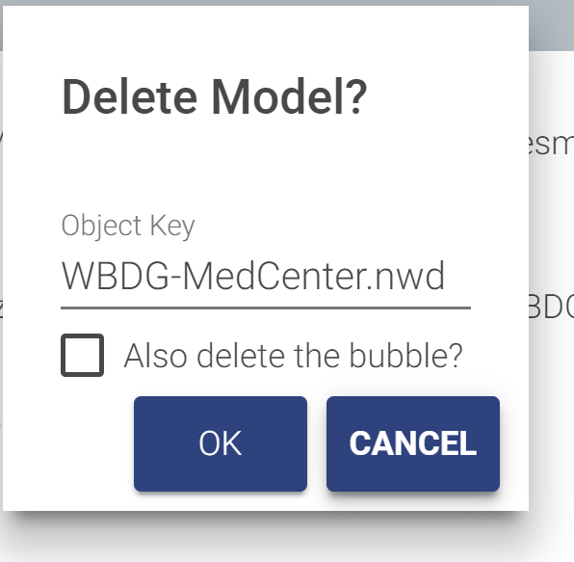

* To delete just the bubble:
  + Open the Model detail dialog as above
  + From the bubble tab, click the trash can (Permanent Delete) icon
  + A confirmation dialog is displayed

Autodesk provide no mechanism to list or search for bubbles, and TRIRIGA maintains no record of model or bubbles outside of the Forge service. Therefore, if you delete the model but not the bubble, you will not be able to later view or delete the bubble, however existing references to the bubble continue to work. So, if a model has been associated with a building and then just the model is deleted, you can continue use the viewer to display the model for that building. If the model file is later re-loaded, it will automatically be associated with the existing bubble.

### Associating Translated Models with Buildings

To view a model from a TRIRIGA application, it must be associated with a building. For TRIRIGA to be able to automatically select and focus on a space or asset, the space or asset must be keyed to the model. If the Building, Space, and Asset records were created by the BIM Connector for Revit, and the model is the Revit file used with the connector, or a Navisworks file derived from the Revit file, this process is automatic.

There are two means of associating a model with a building:

* A single file Revit model may be published directly from Revit using the BIM Connector for Revit. (See section 2.4.3). The publish process handles the model upload, translation and linking to building. It is not necessary to use the BIM Model Management tool.
* For federated Revit models, Navisworks models, and other types of models, the model is linked to the building using the BIM Model Management tool.

Building to Model associations are managed from the Building tab of the BIM Model Management Tool.

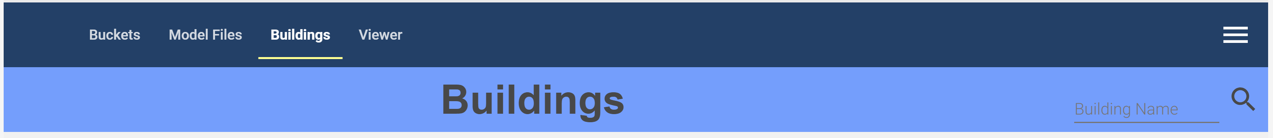

The tab displays all buildings that are accessible to the current user sorted by building name.

* When the tab is first displayed, the first 50 buildings are displayed.
* Additional buildings may be displayed by scrolling to the bottom of the building list.
* The buildings list may be filtered by entering a value in the Building Name field on the toolbar and clicking the search icon. Buildings whose name or address contains the search string are listed.

Each building is displayed as a tile.



Figure 27 - Building to Model Link

* The search button displays a model selection list with the same list of models that is displayed on the Model Files tab. To display models from a different bucket, return to the Model Files tab and select the desired bucket.

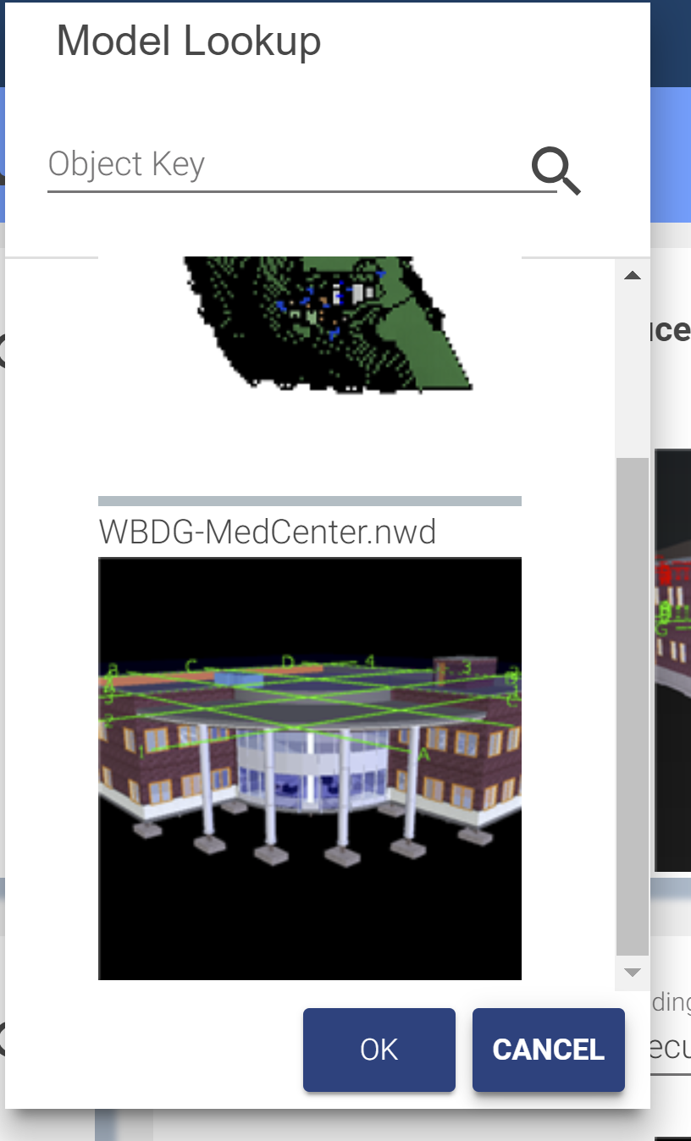

Use the search box to filter the list. This also filters the list on the Model Files tab.  
Select a model to link it to the building. Scroll to the bottom to fetch additional records.

* Click the info icon to display additional details about the link

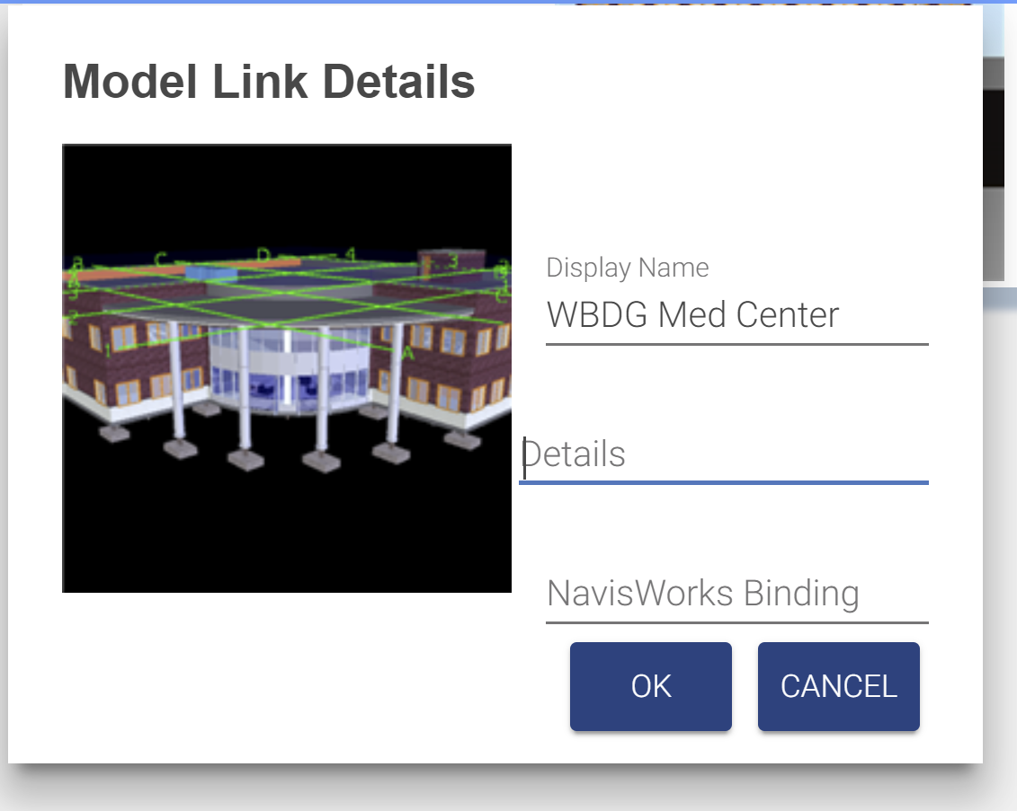

Figure 28 - Building to Model Link Details

* Details: Additional descriptive information not processed by TRIRIGA.
* Navisworks Binding: This is the name of the viewer property which is used to match a viewer element with a TRIRIGA record. If it is not set, it defaults to “GUID”. Some older Navisworks files require “Guid”. It can also be used to create custom binding for other model file types or if the TRIRIGA records were not created by the BIM Connector for Revit.
* Selecting the thumbnail switches to the viewer tab and displays the model in the viewer.

### Previewing Models in the Viewer

Any translated model may be previewed in the viewer included in the BIM Model Management tool. To view a model, select the Viewer tab

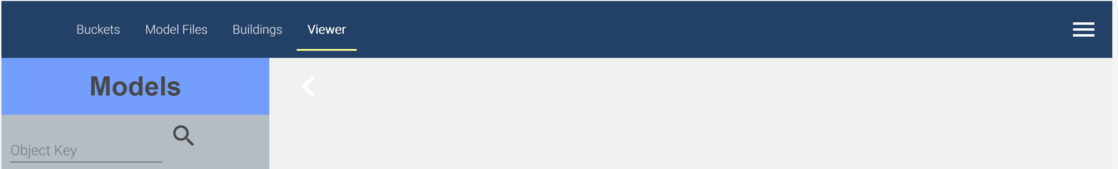

There is a fly-out with a model list. This is the same model list that is displayed on the Model Files tab, except only translated models are shown.

* To view models from a different bucket, return to the Model Files tab, select the desired bucket and refresh the model list.
* Scrolling to the bottom of the list fetches the next 50 models
* The search field filters the existing list. It does not re-fetch the list from the Forge service. The filter match is a substring match.

Select a model in the list to display it in the viewer.

Use the viewer to create saved views (see section 4.4) for use in the Work Tasks application

#### Advanced Viewer Options

There are two advanced options on the BIM Model Management tool menu:

**View Model:** This takes the base 64 encoded model URN and displays the model. The base 64 URN is displayed on the bubble tab of the model details dialog, or it can be obtained from other applications that utilize the Forge viewer.

**Select item in Model:** With the target model displayed, the allows selection of an item in the model based on its raw ID. For Revit models, and Navisworks models derived from Revit, this is the Revit export GUID.

# Using the Autodesk Forge Viewer

The Autodesk® Forge Viewer is integrated into the TRIRIGA UI to support 3D viewing and performing actions from building models. The Viewer is available from three places in the TRIRIGA UI. They are:

* As an additional BIM tab in the Locate application
* As an additional BIM tab for locations and assets in Work Task application
* In the BIM Model Administrant Tool

## TRIRIGA context

When the viewer is used with the Locate or Work Task application it displays the current context of the application. The model displayed is for the building containing the active location or asset. If the active space or asset is keyed to the model, it is also selected in the model and the camera is placed in the model to display that item. For a space, that is near the center of the space. This works well for reasonably regular shaped rooms but for some rooms such as an L- shaped hall, the geometric center is not in the space.

For an asset that is a view that centers the asset in the view and zooms such that the asset fills most of the view. On occasion, an asset can be obscured, and it may be necessary to rotate the view to see the asset.

## Viewer Navigation

Basic and extended viewer navigation and view manipulation is provided by Autodesk as part of the Forge Viewers. These functions are accessed from the bottom toolbar. Various TRIRIGA applications expose more or less of the toolbar, and the toolbar adjusts for screen size so on a small screen some tools are hidden.

### Viewer Toolbar

The left hand three sections of the bottom toolbar are part of the basic viewer package as provided by Autodesk. This provided access to standard viewer navigation features, viewer configuration, and model properties. Several of these features are highlighted below:



Figure 29 - Forge Viewer Toolbar

The right most section of the toolbar contains IBM extensions and access to TRIRIGA specific features.



Figure 30 - TRIRIGA Extension to the Forge Viewer Toolbar

**Search**: The Viewer provides a quick search for items in the model. It searches all model properties for all items for any property value that contains the search string. Any item that has a match is part of the search result and is selected.

**Toggle Zoom to Context:** / 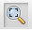 The Toggle Zoom to Context button enables or disables the auto zoom to context when an item is selected in the viewer.

**Zoom to Selection:**  The Zoom to Selection button centers the model on the current selection and zooms the view into the current selection. If multiple items are selected, the view includes all selected items.

**Zoom to Model:**  The Zoom to Model button zooms the view so that the entire model is displayed.

**Apply View ** This button displays a list of all the saved views that are associated with this model. A saved view may be displayed in the viewer by double-clicking the saved view description or by selecting the saved view description then pressing the Apply button.

**Save View**  This button displays the save view dialog to allow the current view to be saved to the TRIRIGA database.

**Show Markup ** This button displays a list of all the Markup that are associated with this model and Work Task. A markup may be displayed in the viewer by double-clicking the markup description or by selecting the markup description then pressing the Apply button (See below).

**Create Markup** 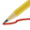 This button switches the viewer to Markup Mode and displays the Markup Toolbar (See below).

### Model Tree

The model tree displays a hierarchical representation of the internal structure of the model. Different types of models have different structures. So, the model tree for a Revit model and a Navisworks model derived from the Revit model are not the same. The model tree can be used to navigate through the model by using its structure. To select individual items or groups of items, and through the context menu, to control how the currently selected item(s) are shown in the model.

If the model tree is open, selecting an item in the model also selects and displays it in the model tree.

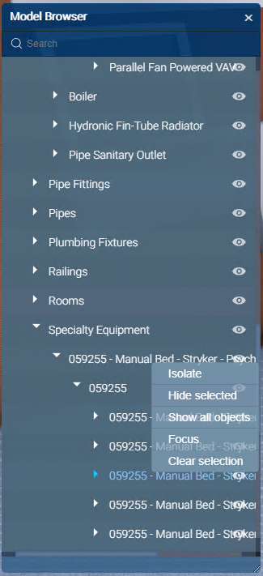

Figure 31- Forge Viewer Model Tree

## Sections

A model can be cut by a section plane in the X,Y,or Z axis, or cut by a box in all three axis at once.

Display the desired section tool and drag the arrow to move the cut plane through the model. The cut plan can be rotated so almost any cut is possible

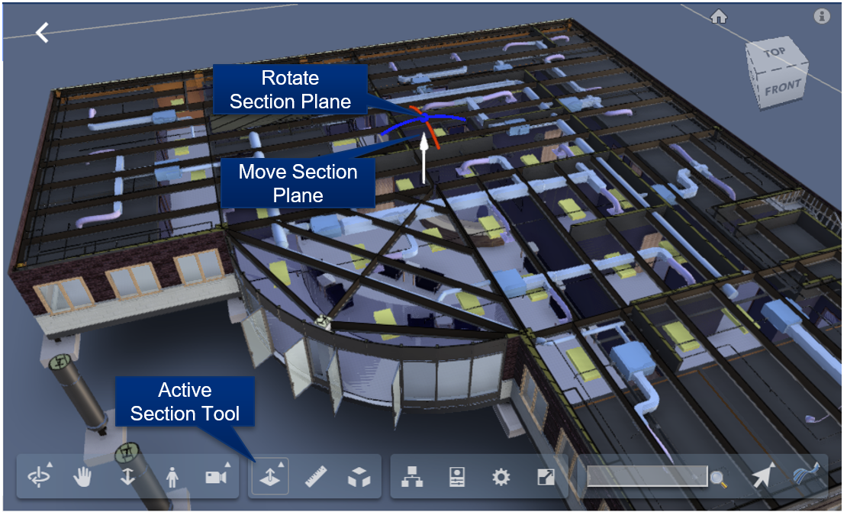

Figure 32 - Forge Viewer Section Tool

|  |  |
| --- | --- |
| Tip | *Use the Z section plane and the top down Orth view to create 2D floor or ceiling plans which can then be store as saved views for later use. A view down the Z axis can be created by clicking on the Top of the view cube* |

## Saved views

Saved Views are available in the viewer embedded in the BIM Administration Tool, and in the Work Task application.

Much of the Viewer state can be captured in a Saved View, stored in the TRIRIGA database and later restored. This includes: The camera position and zoom, the current selection, and section cuts and the selection. Saved views are created from within the viewer. They can be found on the TRIRIGA submenu on the bottom toolbar.



**To create a Saved View:** Setup the desired viewer image, then select the Save View button on the Viewer toolbar. This displays the Save View dialog.

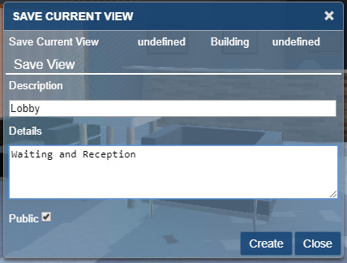

Figure 33 - Saved View Dialog

**Description:** The description is required and identifies the view for later use.

**Details:** Optional addition description

**Public:** Private views are only visible to the user who creates them. Public views are visible to all users with access to the building.

**To restore a view:** Select the Apply Saved View button from the Viewer toolbar. Highlight the desired view and click the Apply button or double-click the desired view.

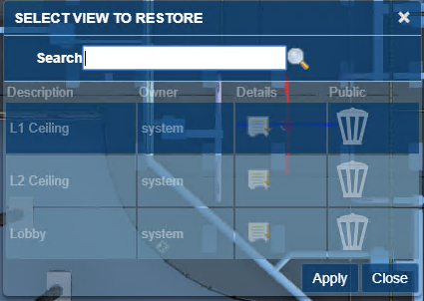

Figure 34 - Apply View Dialog

The dialog only displays the first 20 views for the model. If the view you are looking for is not displayed, use the search field to filter the dialog. The search is a substring match against the description.

**Managing Saved views**: From the BIM Model Management Tool menus select Manage Saved Views. This displays the first 50 saved views. Scroll to the bottom to display additional views. Views may be filtered by description. This is a substring match.

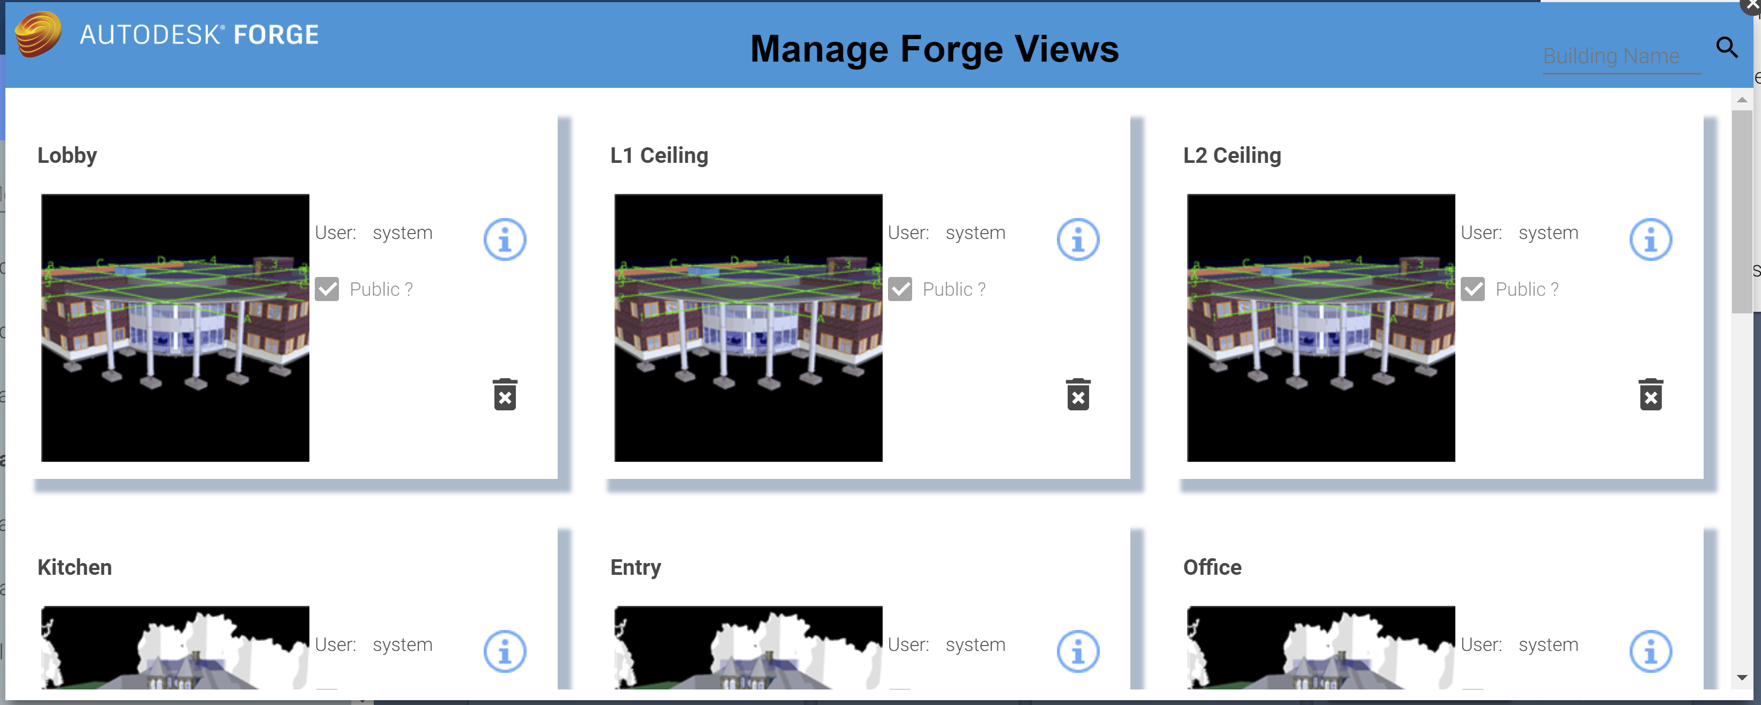

Figure 35 - Manage Forge Views Popup

Views can be deleted from the Manage Saved Views dialog. However, views can only be created from within the Viewer.

Each view is displayed as a tile. The tile has a thumbnail image of the model with which the view is associated.

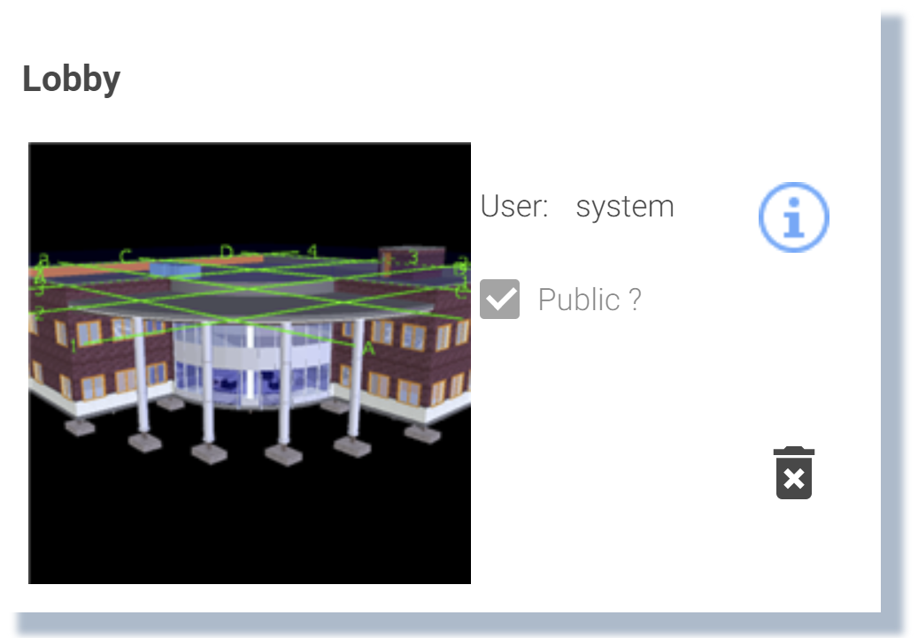

**User:** The login id of the user who created the view. (Read only)

**Public?:** Is the view restricted to its creator?

**Info Icon:** Displays and allows you to update the details information for the saved view

**Trash can icon:** Deletes the saved view.

**Thumbnail image:** Loads the model into the viewer, switches to the viewer tab, and applies the save view to the model.

## Markup

Markup mode provides a set of drawing tools that can be used to draw on top of the view that is displayed at the time the markup mode is entered. Once in markup mode, the view cannot be changed except to zoom and pan. Once complete, the markup can be saved with the work task and displayed later. A work task can have any number of markups associated with it.

When markup mode is entered, the Markup toolbar is displayed:



Figure 36 - Forge Viewer Markup Toolbar

#### Drawing markup

The first section of the Markup tool bar provides a set of drawing tools. The active drawing tool is highlighted. The drawing mechanism differs slightly by tool type:

**Arrow:** Click and drag.

**Cloud:** Click to place each segment. Clicking on the start closes the cloud and allows it to be filled.

**Freehand:** Hold the mouse down and drag.

**Line:** Click to place each segment. Clicking on the start closes the figure and allows it to be filled.

**Oval:** Click and drag to form the bounding box.

**Rectangle:** Click and drag to create diagonally opposite corners.

**Text:** Click to place the top left corner of the text box, then type the text. When complete, click on the background outside the text box to exit edit mode.

#### Markup Properties

The appearance of markup elements can be changed. Selecting the  button displays the Markup Properties dialog:



The dialog has two slightly different forms depending on whether the active drawing tools is the Text tool or any of the other tools.

The property setting remains in effect until it is changed. When a new tool is selected, it uses the current markup properties.

Selecting a previously drawn markup sets the current drawing properties to those used to draw the newly selected markup.

#### Editing Markup

Any previously drawn markup can be selected and edited. Click on the markup to select it. Editing options vary by markup. Generally, markups can be moved, resized, deleted, and in some cases rotated. And they may have their properties edited.

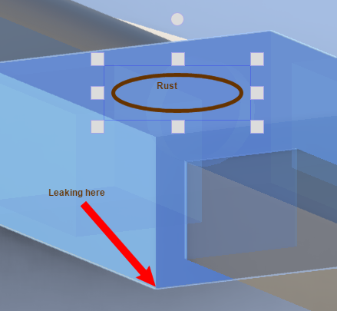

Selecting a markup also makes that markup type the currently selected drawing tool on the Markup toolbar and updates the drawing properties.

#### Save Markup

Select the  Save button to complete the markup session and to save the markup.

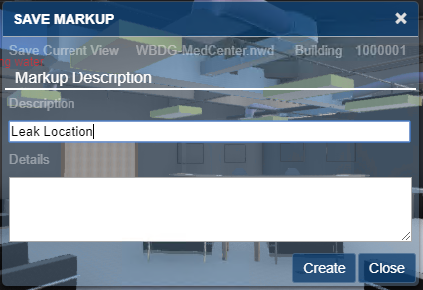

Figure 37 - Save Markup Dialog

When you click the Create button, TRIRIGA saves the just completed markup, the current view, the markup name, and any description with the Work Task.

#### Display Markup

Select the  Display Markup button to display a list of markups that are associated with the work task.

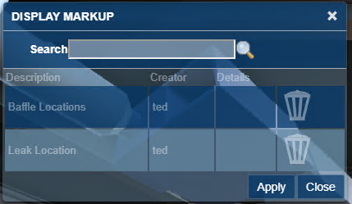

Figure 38- Display Markup Dialog

The dialog only displays the first 20 markups for the model and work task combination If the markup you are looking for is not displayed, use the search field to filter the dialog. The search is a substring match against the description.

Applying a markup restores the view that was used to create the markup and displays the drawing elements of the markup. The Viewer is locked except for zoom and pan until the markup display is closed.

The **Delete** button can be used to delete the associated markup.

# Best Practices

The following are recommended best practices:

* Integrate all Rooms you plan to integrate for all model files before you link spaces to rooms or directly integrate Revit Spaces with TRIRIGA.
* For federated models, the IBM.ModelName value should be unique for each file in the set, and ideally be descriptive of the role the file is playing in the model. For the primary file, IBM.ModelName and IBM.BuildingName can be the same.
* A gross area plan should be created for any level that will be integrated with Revit. Allow Revit to outline the exterior walls. If you subdivide the area plan into additional areas, insure that the entire level is filled with areas.
* If area names are the same as room names, the auto-match can be used to link rooms to areas. If you expect to detach and re-integrate the model with any frequency, this will save work.
* If space names are the same as room names, the auto-match can be used to link rooms to spaces. If you expect to detach and re-integrate the model with any frequency, this will save work.
* Use a Navisworks model in the TRIRIGA viewer to be able to display and select rooms.

**Spaces:** When assets are contained within a TRIRIGA space, it is highly desirable that the relationship is established when the asset is created by the connector. This is problematic for two reasons:

* The model for most large projects is divided into several linked files. Both Rooms and Spaces can map to TRIRIGA spaces. Rooms typically appear in the architectural model, and Spaces in the primary MEP model. Sub-discipline models may not have spaces. Coordinating Rooms and Spaces across models requires a well thought out strategy.
* Room definitions are often not created for service spaces such as plenums, elevator shafts and the like. Many components exist in these areas and may not have a logical association to a defined space although they are access and serviced from a space.

There are several strategies that can be used to address this. These include:

* Rigorously define all spaces such that there is a space definition for every volume in the model including external service areas
* Copy space definitions into linked models. This makes the spaces available in those models. The connector can link the spaces in each model to the Rooms used to create the TRIRIGA space. Even though the copied space has a different internal identifier in each model, Assets in linked paces are Integrated into TRIRIGA using the identity of the original room.
* Allow components to default to floor or facility references.

It is expected that most models will use a combination of these approaches.

# Troubleshooting

## Forge Viewer

**Symptom:** SSL Error

**Resolution:** The signer certificate that is used by the Autodesk Forge service is not in the application server trust store. For WebSphere, this typically is the CellDefaultTrustStore, but it can vary based on the deployment type.

**Symptom:** When using Safari on iOS, the viewer returns a 401 – Unauthorized error and the model load spinner spins forever.

**Resolution:** enable cookies.

**Symptom:** When you use a Navisworks file, the viewer doesn’t zoom to context and when you select an item that should match the imported data it doesn’t

**Resolution:** The Navisworks Binding attribute that is displayed on the Model Link Info dialog in the BIM Model Management Tool may be incorrect. Typically it is either Guid or GUID, but it may be necessary to examine the model properties in the viewer to identify the ID Property/GUID

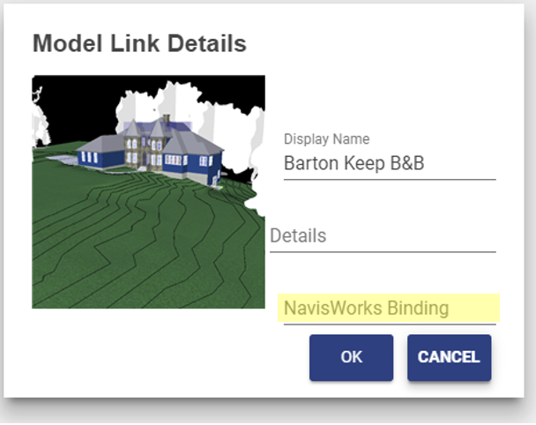

## BIM Connector for Revit

**Symptom:** When opening a new or second model in Revit whether or not the first one is closed; the following error is displayed.

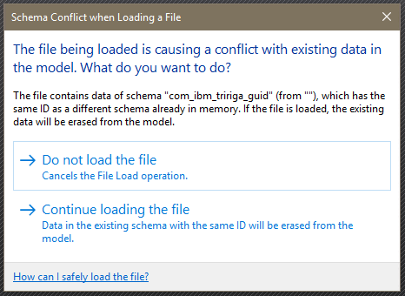

**Resolution:** Continuing to open the model will clear the model GUID which effectively detaches it from TRIRIGA although it doesn’t appear to be detached. If this has happened, the model can be detached and re-integrated.

Closing Revit and re-opening it with the new model bypasses this issue.

**Symptom:** Cannot log into TRIRIGA from the connector as an admin user.

**Resolution:** The number of allowed active admin users has been exceeded. Use the TRIRIGA admin console to close some or all of the active admin users.

Note: logging out of the connector or just closing Revit may not close the session in TRIRIGA.

## Known Limitations

* In the Forge Viewer, large models can generate “out of memory” errors especially in browsers on low memory devices, such as tablets. This can manifest as a console error message or a browser crash.
* If a linked model is detached, it cannot be properly re-integrated. TRIRIGA records created before it was detached are orphaned and cannot be updated from the BIM Connector.
* For the Forge Storage Management, rights granted on storage to other IDs do not in fact grant them rights.
* If the Revit application is open and the BIM Integrator is being updated from a previous build of version 2.6.0 to a later build of the same version, the existing revitintegrator.dll file will not be overwritten. As a result, version 2.6.0 will not reflect the later build of the BIM Integration in the Revit application. To upgrade to the later build, user should close the Revit application, delete the AR integrator folder inside C>ProgramData > IBM >Tririga and install the later build. (Tri-53540)
* Internet Explorer 11 is not supported for BIM Model Management. This prevents the loading of Tools > BIM Model Management. (Tri-54131)
* Within the BIM tab of the perceptive Work Task Service app running on tablets or phones, if one wants to change the font size or the color after entering Markup mode, if the font size is increased beyond 25pt, Bold & Italic options are hidden. Try selecting the Bold & Italic option before changing the font size (Tri-53780).
* In iPhones running either Safari or Chrome, the BIM Viewer is not supported via the "Request Desktop Site" or "Desktop Site" option of the browser menu. The BIM Viewer is only available when those options are not used or you may encounter a black screen in the BIM tab in the perceptive Locate app or the perceptive Work Task Services app. (Tri-53902)

# Appendix REST API support

The TRIRIGA server provides a proxy for the portion of the Autodesk® Forge REST service use by the viewer and the BIM Model Management Tool. This resolves browse Cross Object Resource Scripting (CORS) restrictions, and allows TRIRIGA security to be applied to Forge access.

The proxy endpoints closely follow the original Forge endpoints. In most cases the body, the result, and any error information are passed directly from the original Forge endpoint, See the referenced Forge documentation for details.

The Forge application key and secret are stored in the server HTTP session. The session must be initiated by either calling Authenticate which initializes the session with the credentials provided in the call. Or by calling GetAuthToken. This initializes the session using the credentials stored in the TRIRIGA database in the triBIMConfig business object.

#### Authenticate

Return a Forge auth token with scope viewables:read which is suitable for use by the Forge viewer. If successful, this also initializes the HTTP session with the provide key and secret. These credentials are used for subsequent Forge service calls.

[Forge Endpoint reference](https://developer.autodesk.com/en/docs/oauth/v2/reference/http/authenticate-POST/)

**Path**: /api/p/v1/forge/token

**Method**: GET

**Request Parameters**:

* key: Client ID of the app
* secret: Client secret of the app

#### Get Auth Token

[Forge Endpoint reference](https://developer.autodesk.com/en/docs/oauth/v2/reference/http/authenticate-POST/)

Return a Forge auth token with scope viewables:read which is suitable for use by the Forge viewer. The application key and secret stored in the TRIRIGA database is used to request the token. On success, the credentials are copied into the current HTTP session.

**Path**: /api/p/v1/forge/auth/token

**Method**: GET

**Body**: The result from the Forge service Authenticate Endpoint or:

{

"key": "",

"authenticated": "false";

"error": <TRIRIGA Error message>

}

#### Get Application Key

Gets the application key currently associated with the HTTP session, if there is one, and whether or not the session has successfully authenticated with the Forge service.

**Path**: /api/p/v1/forge/auth/key

**Method**: GET

**Body**: JSON

{

"key”: <Client ID>

"authenticated”: <true/false>

}

#### Logout

Clears the Forge credentials for the HTTML session which disconnects the session from the Forge service. This is only needed or useful if the session was created by Authenticate so session specific credentials were provided.

**Path**: /api/p/v1/forge/auth/logout

**Method**: POST

**Return**: None

#### Get Bucket List

Returns all the buckets associated with the application

[Forge Endpoint reference](https://developer.autodesk.com/en/docs/data/v2/reference/http/buckets-GET/)

**Path**: /api/p/v1/forge/bucket

**Method**: GET

**Request Parameters**:

* region: The region where the bucket resides. Acceptable values: US, EMEA Default: US

#### Query Bucket Details

Returns detailed information about the specified bucket.

[Forge Endpoint reference](https://developer.autodesk.com/en/docs/data/v2/reference/http/buckets-:bucketKey-details-GET/)

**Path**: /api/p/v1/forge/bucket/<bucketkey>

**Method**: GET

**Path Parameters**:

* bucketkey: URL-encoded bucket key for which to get details

#### Create Bucket

Creates a new bucket

[Forge Endpoint reference](https://developer.autodesk.com/en/docs/data/v2/reference/http/buckets-POST/)

**Path**: /api/p/v1/forge/bucket/<bucketkey>

**Method**: POST

**Path Parameters**:

* bucketkey: URL-encoded bucket key for which to get details

**Request Parameters**:

* policy:
* region: The region where the bucket resides. Acceptable values: US, EMEA Default: US

#### Delete Bucket

Deletes the specified bucket which also deletes all models and bubbles associated with the bucket.

Undocumented Forge Endpoint

**Path**: /api/p/v1/forge/bucket/<bucketkey>

**Method**: DELETE

**Path Parameters**:

* bucketkey:

#### Grand Rights to a Bucket

Grants rights to a different application key to access the bucket. Currently of limited functions.

Undocumented Forge Endpoint

**Path**: /api/p/v1/forge/bucket/<bucketkey>/rights/<serviceId>

**Method**: PUT

**Path Parameters**:

* bucketkey: URL-encoded bucket key for which to get details
* serviced: Client ID of the app

**Request Parameters**:

* access:

#### Revoke Rights to a Bucket.

Revokes rights granted by Grant.

Undocumented Forge Endpoint

**Path**: /api/p/v1/forge/bucket/<bucketkey>/rights/<serviced>

**Method**: DELETE

**Path Parameters**:

* bucketkey: URL-encoded bucket key for which to get details
* serviced: Client ID of the app

#### Get Model List

Gets a filtered and paged list of models for the specified bucket.

[Forge Endpoint Reference](https://developer.autodesk.com/en/docs/data/v2/reference/http/buckets-:bucketKey-objects-GET/)

**Path**: /api/p/v1/forge/model/< bucketkey>

**Method**: GET

**Path Parameters**:

bucketkey **Request Parameters**:

* name: String to filter the result set by. The result set is restricted to items whose objectKey begins with the provided string.
* start: The position to start listing the result set. This parameter is used to request the next set of items, when the response is paginated. The fetch the next page of data, this should be the last item returned on the current page.
* pagesize: The number of objects to return in the result set. Acceptable values = 1 - 100. Default = 10.

#### Query Model Details

Returns detailed information about a single model file.

[Forge Endpoint Reference](https://developer.autodesk.com/en/docs/data/v2/reference/http/buckets-:bucketKey-objects-:objectName-details-GET/)

**Path**: /api/p/v1/forge/model/<bucketkey>/object

**Method**: GET

**Path Parameters**:

* bucketkey: URL-encoded bucket key for which to get details

**Request Parameters**:

* objectKey: URL-encoded object name to get details for

#### Upload Model

Uploads a model file to the selected bucket

[Forge Endpoint Reference](https://developer.autodesk.com/en/docs/data/v2/reference/http/buckets-:bucketKey-objects-:objectName-resumable-PUT/)

**Path**: /api/p/v1/forge/model/<bucketkey>/object

**Method**: PUT

**Path Parameters**:

* bucketkey: URL-encoded bucket key for which to get details

**Request Parameters**:

* objectKey: URL-encoded object name to get details for

#### Delete Model

Deletes a model. If the model has been translated to a viewable bubble, the bubble is not deleted.

[Forge Endpoint Reference](https://developer.autodesk.com/en/docs/data/v2/reference/http/buckets-:bucketKey-objects-:objectName-DELETE/)

**Path**: /api/p/v1/forge/model/<bucketkey>/object

**Method**: DELETE

**Path Parameters**:

* bucketkey: URL-encoded bucket key for which to get details

**Request Parameters**:

* objectKey: URL-encoded object name to get details for

#### Query Bubble Details

Query details about a translated model, or a model in the process of being translated. This can be used to get status and progress on the translation process.

[Forge Endpoint Reference](https://developer.autodesk.com/en/docs/model-derivative/v2/reference/http/urn-manifest-GET/)

**Path**: /api/p/v1/forge/bubble

**Method**: POST

**Request Parameters**:

* objectKey: URL-encoded object name to get details for

#### Delete Bubble

Delete the viewable bubble resulting from model translation

[Forge Endpoint Reference](https://developer.autodesk.com/en/docs/model-derivative/v2/reference/http/urn-manifest-DELETE/)

**Path**: /api/p/v1/forge/bubble

**Method**: DELETE

#### Translate Model to Bubble

Translate a model file into a viewable bubble. The translated format is required for use with the Forge viewer

[Forge Endpoint Reference](https://developer.autodesk.com/en/docs/model-derivative/v2/reference/http/job-POST/)

**Path**: /api/p/v1/forge/bubble/translate

**Method**: POST

**Request Parameters**:

* rootFileName: The root filename of the compressed file. Mandatory if the upload file is a .zip file.
* region: The region where the bucket resides. Acceptable values: US, EMEA Default: US

#### Get Thumbnail

Retrieves the thumbnail image for the translated bubble. This url is suitable for as a src url attribute of a html img element.

[Forge Endpoint Reference](https://developer.autodesk.com/en/docs/model-derivative/v2/reference/http/urn-thumbnail-GET/)

**Path**: /api/p/v1/forge/bubble/<urn>/thumbnail

**Method**: GET

**Path Parameters**:

* urn: The Base64-encoded (URL-safe) design URN

Return: octet steam with thumbnail image.

 ®

© Copyright IBM Corporation 2018

IBM United States of America

Produced in the United States of America

US Government Users Restricted Rights - Use, duplication or disclosure restricted by GSA ADP Schedule Contract with IBM Corp.

IBM may not offer the products, services, or features discussed in this document in other countries. Consult your local IBM representative for information on the products and services currently available in your area. Any reference to an IBM product, program, or service is not intended to state or imply that only that IBM product, program, or service may be used. Any functionally equivalent product, program, or service that does not infringe any IBM intellectual property right may be used instead. However, it is the user's responsibility to evaluate and verify the operation of any non-IBM product, program, or service.

IBM may have patents or pending patent applications covering subject matter described in this document. The furnishing of this document does not grant you any license to these patents. You can send license inquiries, in writing, to:

IBM Director of Licensing  
IBM Corporation  
North Castle Drive  
Armonk, NY 10504-1785   
U.S.A.

**The following paragraph does not apply to the United Kingdom or any other country where such provisions are inconsistent with local law:**

INTERNATIONAL BUSINESS MACHINES CORPORATION PROVIDES THIS PAPER “AS IS” WITHOUT WARRANTY OF ANY KIND, EITHER EXPRESS OR IMPLIED, INCLUDING, BUT NOT LIMITED TO, THE IMPLIED WARRANTIES OF NON-INFRINGEMENT, MERCHANTABILITY OR FITNESS FOR A PARTICULAR PURPOSE. Some states do not allow disclaimer of express or implied warranties in certain transactions, therefore, this statement may not apply to you.

This information could include technical inaccuracies or typographical errors. Changes may be made periodically to the information herein; these changes may be incorporated in subsequent versions of the paper. IBM may make improvements and/or changes in the product(s) and/or the program(s) described in this paper at any time without notice.

Any references in this document to non-IBM Web sites are provided for convenience only and do not in any manner serve as an endorsement of those Web sites. The materials at those Web sites are not part of the materials for this IBM product and use of those Web sites is at your own risk.

IBM may have patents or pending patent applications covering subject matter described in this document. The furnishing of this document does not give you any license to these patents. You can send license inquiries, in writing, to:

IBM Director of Licensing

IBM Corporation

4205 South Miami Boulevard

Research Triangle Park, NC 27709 U.S.A.

All statements regarding IBM's future direction or intent are subject to change or withdrawal without notice, and represent goals and objectives only.

This information is for planning purposes only. The information herein is subject to change before the products described become available.

If you are viewing this information softcopy, the photographs and color illustrations may not appear.

**Trademarks**

IBM, the IBM logo, and ibm.com are trademarks or registered trademarks of International Business Machines Corporation in the United States, other countries, or both. If these and other IBM trademarked terms are marked on their first occurrence in this information with a trademark symbol (® or ™), these symbols indicate U.S. registered or common law trademarks owned by IBM at the time this information was published. Such trademarks may also be registered or common law trademarks in other countries. A current list of IBM trademarks is available on the web at "Copyright and trademark information" at <http://www.ibm.com/legal/copytrade.shtml>.

Autodesk, the Autodesk logo, BIM360, Navisworks, Revit, Forge are registered trademarks or trademarks of Autodesk, Inc., and/or its subsidiaries and/or affiliates in the USA and/or other countries. All other brand names, product names, or trademarks belong to their respective holders. Autodesk reserves the right to alter product and services offerings, and specifications and pricing at any time without notice, and is not responsible for typographical or graphical errors that may appear in this document. © [2018] Autodesk, Inc. All rights reserved.

Microsoft, Windows, Windows NT, and the Windows logo are trademarks of Microsoft Corporation in the United States, other countries, or both.

Other company, product, or service names may be trademarks or service marks of others.